
Department of Computer Science
Faculty of Computing and Information Technology (FCIT)
University of the Punjab

TruthLens– An Explainable AI System for Fake News Detection

Final Year Project Design

By

Abdullah Liaqat BCSF22M520
Muhammad Sajjad BCSF22M540

Under the supervision of
Prof. Umair Babar

Bachelor of Science in Computer Science (2022-2026)
FACULTY OF COMPUTING & INFORMATION TECHNOLOGY (FCIT),
UNIVERSITY OF THE PUNJAB, LAHORE.

DECLARATION

We hereby declare that this software, neither whole nor as a part has been copied out from any source. It is further declared that we have developed this software and accompanied report entirely on the basis of our personal efforts. If any part of this project is proved to be copied out from any source or found to be reproduction of some other, we will stand by the consequences. No portion of the work presented has been submitted for any other degree or qualification of this or any other university or institute of learning.

Signature: -------------------- Signature: ---------------------
Abdullah Liaqat [BCSF22M520] Muhammad Sajjad [BCSF22M540]

CERTIFICATE OF APPROVAL

It is to certify that the final year design project (FYDP) of BSCS “TruthLens-An Explainable AI System for Fake News Detection” was developed by
Abdullah Liaqat ( BCSF22M520 ) , Muhammad Sajjad ( BCSF22M540 under the supervision of “Prof. Umair Babar” in my opinion; it is fully adequate, in scope and quality for the degree of Bachelors of Science in Computer Science.

Signature:
FYDP Supervisor:

Signatures (Faculty Advisory Committee (FAC)

Signatures
Name
 | FAC1 | FAC2 | FAC3

Signature:
Head of FYDP Coordination Office:

Signature:--------------------------------------- Dated:
Chairperson, Department of Computer Science

Abstract
The rapid spread of misinformation across digital platforms has created a critical need for reliable and intelligent fact-checking systems. This project, TruthLens, presents an advanced fake news detection framework that combines deep learning with real-time data verification to enhance credibility assessment. The system leverages a fine-tuned RoBERTa (Robustly Optimized BERT Pretraining Approach) model for accurate classification of news content as real or fake, utilizing benchmark datasets such as LIAR, Kaggle Fake News, and FakeNewsNet.
To move beyond static prediction, the proposed system integrates real-time news APIs and fact-checking databases, enabling dynamic validation of incoming information against up-to-date sources. This hybrid approach ensures that predictions are not only model-driven but also contextually supported by current, real-world data. Additionally, explainability techniques including LIME and SHAP are incorporated to provide transparent insights into model decisions, improving user trust and interpretability.
The system is deployed through a full-stack architecture consisting of a React-based frontend, a Flask backend, and a RESTful API structure for seamless communication. Experimental results demonstrate that the integration of transformer-based modeling with real-time verification significantly enhances detection performance and practical usability. TruthLens aims to serve as a scalable and intelligent solution for combating misinformation in modern digital ecosystems.

ACKNOWLEDGMENT
We would like to express our deepest gratitude to our Respected Supervisor, Mr. Umair Babar, for his continuous guidance, valuable suggestions, and unwavering support throughout the development of our Final Year Project, “TruthLens: Fake News Detection System.” His insightful feedback and encouragement played a crucial role in refining our ideas and successfully completing this project.
We are also sincerely thankful to our Department and Faculty Members for providing us with the knowledge, resources, and a supportive academic environment that enabled us to carry out this work effectively. Their teaching and mentorship throughout our degree have been instrumental in building the foundation required for this project.
We would like to extend our appreciation to all Organizations and Platforms that provided open datasets and APIs, including real-time news and fact-checking sources, which significantly enhanced the functionality and practical relevance of our system.
Finally, we express our heartfelt thanks to our Families for their constant encouragement, patience, and moral support throughout our academic journey. Their belief in us has been a source of strength and motivation.
This project stands as a result of the collective efforts and support of all those mentioned above.

Abbreviations
The following abbreviations are used throughout this report:

Abbreviation | Full Form | Description
AI | Artificial Intelligence | Technology enabling machines to simulate human intelligence and decision-making
API | Application Programming Interface | Interface allowing communication between different software systems
BERT | Bidirectional Encoder Representations from Transformers | Pre-trained transformer language model by Google
BPE | Byte-Pair Encoding | Subword tokenization algorithm used in RoBERTa
CORS | Cross-Origin Resource Sharing | Browser security mechanism controlling cross-origin HTTP requests
CPU | Central Processing Unit | Primary processor used for general computation
CRUD | Create, Read, Update, Delete | Basic database operations
DB | Database | Structured system for storing and managing data
DFD | Data Flow Diagram | Diagram showing how data flows through a system
ER | Entity Relationship | Diagram showing database entities and their relationships
FCIT | Faculty of Computing and Information Technology | Academic faculty overseeing computing programs
FR | Functional Requirement | A requirement specifying system behaviour or function
GPU | Graphics Processing Unit | Specialized processor for parallel computation and ML training
HTML | HyperText Markup Language | Standard markup language for web pages
HTTP | HyperText Transfer Protocol | Protocol used for communication over the web
JSON | JavaScript Object Notation | Lightweight data format used for API data exchange
JWT | JSON Web Token | Secure method for transmitting authentication information
LIME | Local Interpretable Model-Agnostic Explanations | XAI technique explaining individual model predictions
LLM | Large Language Model | AI model trained on large text datasets for language tasks
ML | Machine Learning | Subset of AI focused on learning patterns from data
MLP | Multi-Layer Perceptron | Type of feedforward artificial neural network
NLP | Natural Language Processing | AI field focused on understanding and processing human language
NFR | Non-Functional Requirement | A requirement specifying system quality attributes
ORM | Object-Relational Mapping | Technique for converting between object and relational data
PBKDF2 | Password-Based Key Derivation Function 2 | Cryptographic algorithm for secure password hashing
REST | Representational State Transfer | Architectural style for designing web services
RoBERTa | Robustly Optimized BERT Pretraining Approach | Improved variant of BERT with dynamic masking
SDLC | Software Development Life Cycle | Process followed for developing software systems
SHAP | SHapley Additive exPlanations | XAI technique based on cooperative game theory
SPA | Single Page Application | Web application loading a single HTML page dynamically
SQL | Structured Query Language | Language used for managing relational databases
SQLite | SQLite Database | Lightweight file-based relational database engine
TF-IDF | Term Frequency-Inverse Document Frequency | Statistical measure for text feature extraction
UAT | User Acceptance Testing | Testing phase to validate system usability and requirements
UI | User Interface | Visual elements through which users interact with a system
UX | User Experience | Overall experience of a user interacting with a system
XAI | Explainable Artificial Intelligence | AI methods providing transparent, understandable decisions
XSS | Cross-Site Scripting | Web security vulnerability allowing malicious script injection

Table of Contents
Chapter 1: Introduction 18
1.1 Background 18
1.2 Problem Statement 19
1.3 Proposed Solution 20
1.4 Main Objectives 20
1.5 Assumptions & Constraints 21
1.5.1 Assumptions 21
1.5.2 Constraints 21
1.6 Project Scope 21
1.7 Software Development Life Cycle Model 22
Chapter 2: Requirement Analysis 23
2.1 Literature Review 23
2.1.1 Industrial Efforts in Misinformation Detection 23
2.1.2 Evolution of Academic Approaches 23
2.1.3 Early Machine Learning Techniques 23
2.1.4 Deep Learning-Based Models 24
2.1.5 The Transformer Revolution 24
2.1.6 Explainable Artificial Intelligence (XAI) in NLP 25
2.1.7 Hybrid and Integrated Approaches 25
2.1.8 Comparative Analysis 26
2.2 Research Gap and Motivation 27
2.3 Requirements Elicitation 28
2.3.1 Functional Requirements 28
2.3.2 Non-Functional Requirements 28
2.3.3 Requirements Traceability Matrix 29
2.4 Use Case Descriptions 30
2.4.1 Use Case 1: Analyze News 30
2.4.2 Use Case 2: Visualize Explanations 30
2.4.3 Use Case 3: Evaluate Model Performance 30
2.4.4 Use Case 4: Manage History 31
Chapter 3: Proposed Methodology and System design 32
3.1 Overview 32
3.2 Datasets 34
3.3 Data Preprocessing 34
3.3.1 Steps and tools 35
3.3.2 Token length normalization (example) 35
3.4 Model Architecture 36
3.4.1 Self-attention mechanism 36
3.4.2 Encoder and classification 37
3.4.3 Loss function and optimization 37
3.4.4 Backend Class Diagram 40
3.5 Explainability Techniques 40
3.5.1 LIME-local linear surrogate 40
3.5.2 SHAP- Shapley value explanations 41
3.5.3 Integration rules and caching 41
3.6 External Verification Architecture 43
3.7 Flow of Methodology (textual synthesis) 44
3.8 System Architecture and Component Interaction 47
3.8.1 Data Flow 48
3.9 Algorithm and Model Selection 48
3.9.1 Why Transformer-Based Models? 48
3.9.2 Why RoBERTa Specifically? 48
3.9.3 Fine-Tuning Strategy 49
3.8.5 Explainability Compatibility 49
3.8.6 Summary of Model Selection Justification 49
Chapter 4: Testing 52
4.1 Test Case Design 52
4.2 Unit Testing 52
4.2.1 Backend Module Tests 52
4.2.2 Authentication Module Tests 53
4.3 Integration Testing 53
4.3.1 Integration Test Cases 53
4.4 Functional Testing 54
4.4.1 Test Scenario 1: Verified Fake Claim 55
4.4.2 Test Scenario 2: Verified Real Claim – Fact Check Match 55
4.4.3 Test Scenario 3: Conflict Between Model and Fact Check 55
4.4.4 Test Scenario 4: Model-Only – No External Match 55
4.5 Performance Testing 56
4.6 User Acceptance Testing 56
Chapter 5: Implementation 57
5.1 Work Breakdown Structure 57
5.2 Team Roles and Responsibilities 59
5.3 Tools and Technologies 60
5.3.1 Programming Language 60
5.3.2 Development Platforms 60
5.3.3 Libraries and Frameworks 60
5.3.4 Web and API Development 61
5.3.5 Database Management 61
5.3.6 Development Tools and Version Control 62
5.3.7 Justification 62
5.4 Implementation Details 62
5.4.1 RoBERTa Fine-Tuning 62
5.4.2 Hybrid Rule Engine 62
5.4.3 External Verification Pipeline 63
5.4.4 JWT Authentication 63
5.4.5 Frontend Modularisation 63
5.5 System Screenshots 65
5.5.1 Home Page 65
5.5.2 Sign Up and Login 65
5.5.3 Analysis Results 67
5.5.4 Explainability – LIME View 68
5.5.6 Explainability – SHAP View 71
5.5.7 Evaluation Dashboard 71
5.5.8 History Page 73
5.6 Challenges During Implementation 73
5.6.1 Limited Computational Resources 73
5.6.2 High Computational Cost of Explainability (SHAP) 74
5.6.2 RoBERTa Tokenizer Compatibility with LIME and SHAP 74
The solution was to use SHAP's Text masker with the same BPE split expression and to configure LIME's split_expression to match token boundaries, ensuring explanations correspond meaningfully to recognizable words. 75
5.6.3 NewsAPI False Positive Matching 75
5.6.4 Frontend Modularisation and framer-motion Compatibility 75
5.6.5 JWT State Management Across Route Changes 75
5.6.7 Integration Complexity Across System Components 76
5.6.8 Latency and Interpretability Trade-off 76
5.6.9 Time Constraints and Academic Deadlines 76
5.6.10 Development and Debugging Challenges 77
5.6.11 Engineering Insight Gained 77
Chapter 6: Testing and Code Quality Assurance 78
6.1 Overview 78
6.2 Requirement Quality Assessment 78
6.2.1 Requirement Coverage Analysis 78
6.2.2 Jira Sprint Summary 79
6.2.3 Jira Requirement Quality Verification 80
6.3 Code Quality Analysis 80
6.3.1 Codebase Structure 80
6.3.2 Code Quality Metrics 82
6.3.3 Static Analysis Findings 83
6.3.4 Security Assessment 85
6.4 AI Output Validation 85
6.4.1 Model Calibration Assessment 85
6.4.2 Adversarial Testing 86
6.4.3 Consistency Testing 86
6.4.4 External Source Override Accuracy 86
6.5 Performance and Load Testing 87
6.6 Continuous Integration Recommendations 87
Chapter 7: Conclusion and Future Work 89
7.1 Conclusion 89
7.2 Critical Appraisal 90
7.2.1 Strengths 90
7.2.2 Limitations 90
7.3 Future Work and Roadmap 91
7.3.1 Short-Term Enhancements (3–6 months) 91
7.3.2 Medium-Term Enhancements (6–12 months) 91
7.3.3 Long-Term Vision 91
7.4 Final Remarks 92
References 94

List of Figures
Figure 3.1: System Architecture Overview 32
Figure 3.2: preprocessing module 35
Figure 3.3: Model Training 38
Figure 3.4: Backend Class Diagram 39
Figure 3.5: Shap Explanation Generation 41
Figure 3.6: DFD levlel-1 42
Figure 3.7: Fake news prediction 44
Figure 3.8: Metrics Evaluation 45
Figure 3.9: Sequence Diagram 46
Figure 3.10: Component Diagram 49
Figure 3.11: Frontend Class Diagram 50
Figure 5.1: Home Page 64
Figure 5.2: Signup Page with Password Strength Indicator 65
Figure 5.3: Login Page 66
Figure 5.4: Analysis Result 67
Figure5.5: Explanation Screen 68
Figure 5.6: LIME Explainability 69
Figure 5.7: SHAP Explainability 70
Figure 5.8: Model evalauation 71
Figure 5.9:Prediction History 72

List of Tables
Table 2.1: Literature Comparison 25
Table 2.2: Requirements Traceability Matrix 28
Table 3.1: Training Datasets 33
Table 3.2: Preprocessing Operations 34
Table 3.3: Model Hyperparameters 36
Table 3.4: Model Architecture Comparison 47
Table 4.1: Backend Unit Test Cases 51
Table 4.2: Authentication Unit Test Cases 52
Table 4.3: Integration Test Cases 52
Table 4.4: Performance Test Results 55
Table 4.5: UAT Feedback Summary 55
Table 5.1: Work Breakdown Structure 56
Table 5.2: Team Roles and Responsibilities 58
Table 5.3: Libraries and frameworks 59
Table 6.1: Requirement Quality Summary 77
Table 6.2: Sprint Completion Summary 78
Table 6.3: Codebase Module Summary 79
Table 6.4: Code Quality Summary 81
Table 6.5: Static Analysis Issues 82
Table 6.6: AI Validation Summary 85

Chapter 1: Introduction

1.1 Background
These days, digital media increases the spread of false news through the release of information by social media and online news platforms without verification. Although this connectivity has indeed promoted the sharing of information in real time, it has also provided a fertile ground for the dissemination of misinformation and fake news. The increasing availability of content-generation tools has blurred the line between legitimate journalism and fake stories. This has led to the development and emergence of misinformation as a multifaceted sociotechnical issue that is profoundly affecting society, politics, and the economy [1].
In recent years, the literature on fake news detection and explainable artificial intelligence (XAI) has expanded at a high rate. Early systems were rule-based and statistical; however, they were not flexible enough to accommodate language variations. Subsequently, classical machine learning algorithms like Naive Bayes, Support Vector Machines (SVM), and Decision Trees took over, later being outperformed by neural networks and then, most recently, transformer-based neural networks like RoBERTa [6]. Although these are made, one persistent weakness remains: interpretability. Users and policymakers require models that cannot only categorise news as fake or real but also provide transparent and verifiable explanations for their reasoning [2], [9].
Despite these advances, a persistent weakness remained: interpretability. Users, journalists, policymakers, and researchers require systems that not only classify news as real or fake but also provide transparent, verifiable explanations for their predictions [2][9]. This requirement drove the development of Explainable AI (XAI) frameworks such as LIME and SHAP, which can attribute model decisions to specific input features.
This report documents the complete development and evaluation of TruthLens, an explainable fake news detection system that integrates a fine-tuned RoBERTa transformer with LIME and SHAP explainability modules, a hybrid rule engine, real-time external source verification through NewsAPI and Google Fact Check, and a full-stack web application with JWT-based user authentication.

1.2 Problem Statement
The blistering development of the online information resulted in the increasing number of individuals who do not know how to draw the line between genuine journalism and a fake narrative. Even though deep learning has contributed greatly to the detection of fake-news, most of the models are black-box machines; they can make accurate predictions but fail to give a reason why a given article is either fake or real [5][6].
This interpretability results in a high level of trust deficit. Stakeholders like journalists, policymakers and researchers might be reluctant to use automated systems that are unable to explain their decisions. An explanatory predictive model would pose a danger of creating a bias that reinforces, spreads doubt, and enhances a lack of credibility in sensitive socio-political situations. In this manner, achieving transparency is as crucial as improving accuracy in the detection of misinformation.
Naive Bayes or Support Vector Machines (SVM) are traditional models that have been moderately successful but have poor contextual comprehension [9]. Transformer-based models, such as BERT [6], incorporate contextual embeddings that capture in-depth semantic meaning, thereby significantly enhancing classification accuracy. However, these models are yet to be interpretable- people are unable to understand how a prediction came about.
In the meantime, Explainable AI (XAI) procedures like LIME [7] and SHAP [8] have been developed to explain intricate machine-learning models by determining which words or characteristics affect predictions most significantly. Although these methods are promising, they were mostly presented in isolation in academic literature, but were not combined into fake-newsdetection systems that non-technical users can use.
Therefore, the core research question to be pursued in this project is whether a unified, explicable, and high-precision fake-news-detection system can unify state-of-the-art transformer models with interpretable AI engines in a manner that is computationally efficient and easy to use.
Problem Definition
Which algorithm can be designed to detect fake news and combine the precision of the transformer-based algorithms (like ROBERTa) with the clarity of the XAI techniques (LIME and SHAP) to offer real-time, transparent, and credible classification outputs using a web-based interface?

1.3 Proposed Solution
The proposed system processes a text-based news input, applies a trained machine-learning model, and produces a classification of real or fake. To increase transparency, the system highlights contributing words using explainability techniques such as LIME and SHAP.
The solution is designed as:
- A text-analysis tool
- Built upon established, labeled datasets
- Capable of showing why certain patterns may indicate misinformation
This allows users to examine the linguistic structure of news rather than relying solely on manual judgment.

1.4 Main Objectives
The primary objectives are:
- To develop a machine-learning model capable of analyzing textual news data using modern transformer-based architecture.
- To emphasize the most significant textual elements that affect the classification, enhance user knowledge and credibility.
- To integrate real-time external source verification through NewsAPI and Google Fact Check, enabling the system to cross-reference predictions against curated fact-check databases
- To develop a complete full-stack web application with user authentication, per-user prediction history, and an intuitive interface accessible to non-technical users.

- To develop a workflow, research-grade and structured, to include the analysis of the dataset, its preprocessing, training a model, and integration of the system.
Secondary goals are exploration of data sets, comparative analysis and creating reusable elements to be extended in the future.

1.5 Assumptions & Constraints

1.5.1 Assumptions
- Textual news items contain identifiable linguistic patterns that can be learned from structured datasets.
- Users will provide the news text directly (no external scraping or multimedia content).
- The datasets used for training represent a sufficient variety of writing styles and misinformation patterns for a prototype system.
- External APIs (NewsAPI and Google Fact Check) return relevant results for English-language news queries within acceptable latency bounds

1.5.2 Constraints
- The system operates on text analysis and does not perform image or video analysis.
- The model is trained on available labelled datasets and depends on the quality and labelling consistency of those datasets.
- External API availability and rate limits may affect real-time verification response times.
- The system is deployed locally for demonstration purposes; cloud deployment infrastructure is outside the scope of this phase.

1.6 Project Scope
The scope of TruthLens is intentionally defined to focus on textual features within labeled datasets. The project includes:
- Dataset collection, preprocessing, and combined training across multiple benchmark corpora
- Fine-tuning of a RoBERTa transformer model for binary fake news classification
- Integration of LIME for synchronous local explanations and SHAP for on-demand global explanations
- Development of a hybrid rule engine for credibility signal analysis
- Real-time integration with NewsAPI and Google Fact Check Tools API for external verification
- Full-stack web application with JWT authentication, protected routes, and per-user history
- Comprehensive testing including unit, integration, functional, and performance testing
The project does not include:
- Real-time social media scraping
- Multimedia or image-based misinformation detection Monitoring of changing news reports
- Processing of non-textual or mixed-media content.
This breadth makes sure that the findings are consistent, explicable as well as that they can be measured academically.

1.7 Software Development Life Cycle Model
The SDLC Model of the project is an Incremental one and each component of the project is developed and tested in stages. This approach supports:
- Dataset collection, exploration, and preprocessing
- Model training, hyperparameter tuning, and evaluation
- LIME integration and synchronous explanation generation
- SHAP module development and on-demand explanation generation
- Rule engine design and calibration
- External API integration (NewsAPI and Google Fact Check)
- Frontend development, JWT authentication, and modularisation
- Testing, quality assurance, and documentation
This incremental approach supported early model experimentation, progressive integration of explainability modules, and iterative frontend development based on supervisor feedback.

Chapter 2: Requirement Analysis

2.1 Literature Review

2.1.1 Industrial Efforts in Misinformation Detection
The disruptive technology giants, including Facebook, Twitter (now X), and Google, have installed large-scale automated systems that fight against misinformation. The platforms combine both a combination of keyword-based filtration, crowdsourced flagging, and machine learning algorithms to identify potentially misleading content [1].
Facebook launched its Third-Party Fact-Checking Program that is based on automated classifiers, as well as human reviewers. Twitter used community-based labelling through Birdwatch and introduced automated tagging of posts that had breached misinformation policies. Although these systems have been effective at creating limits on the spread of fake claims by the virus, researchers have criticized them for having a low degree of transparency and interpretability - users often get flags without knowing the reasoning behind them.
NewsGuard and Media Bias/Fact Check (MBFC) are independent tools to determine the credibility of news using semi-automated processes. These tools use a combination of rule-based indicators (e.g., domain reliability, ownership bias) and expert rating, in the form of browser extensions that show credibility scores. Nevertheless, their scalability is low, and they do not cover languages other than English, as well as the expert-driven approaches, as argued by Alalawi et al. [1].
Accordingly, as industrial systems are scalable and reachable, they lose explainability and accountability, which are the core of user trust. These deficiencies constitute the basic impetus to scholarly research on interpretable fake news detection.

2.1.2 Evolution of Academic Approaches

2.1.3 Early Machine Learning Techniques
The earliest academic works designed fake news detection as a supervised classification task with shallow machine learning algorithms. The major models were Naïve Bayes, SVMs, and Logistic Regression [9]. These systems were heavily reliant on manual textual characteristics, including term frequency-inverse document frequency (TF-IDF), sentiment polarity, and word variety.
Indicatively, Shu et al. [9] point out that initially systems performed moderately clearly on curated datasets but failed to do so across domains - models trained on a specific dataset (e.g., political news) underperformed when applied to another (e.g., health misinformation). These strategies were fragile and failed to scale because they relied on the feature-engineering dependency.
Moreover, these models lacked the ability to model rich semantic and syntactic relations among words, a vital component in identifying advanced instances of misinformation that employ linguistic framing techniques to convince people, as opposed to a blunt falsehood.

2.1.4 Deep Learning-Based Models
To address such shortcomings, researchers have resorted to Deep Neural Networks (DNNs), specifically Convolutional Neural Networks (CNNs) and Recurrent Neural Networks (RNNs). CNNs learned local semantics of phrases, whereas RNNs, such as LSTM and GRU, learned the sequential text dependencies.
Nevertheless, according to Berrondo-Otermin and Sarasa-Cabezuelo [4], deep architectures also faced challenges with long-range dependencies, which caused the loss of information in long articles. RNNs were more context-sensitive than classical ML but had a weakness of vanishing gradients and expensive training. In addition, their interpretability remained poor, and the generated features were not easily understandable by humans.

2.1.5 The Transformer Revolution
The aim of the paper by Vaswani et al. [5] was to introduce the Transformer architecture, which became a game-changer in natural language processing (NLP). The Attention Is All You Need paper substituted the sequential processing method with an attention mechanism, enabling models to consider all word dependencies simultaneously. This architectural advancement allowed the construction of large pre-trained language models like BERT, RoBERTa, and DistilBERT, which are more effective in contextual understanding and generalisation as compared to earlier architectures.
BERT established a new baseline through bidirectional pre-training, and its successor RoBERTa improved upon it by removing the next-sentence prediction objective, training on larger corpora with larger batches, and applying dynamic masking, achieving superior performance on downstream classification tasks. Transformer models now deliver state-of-the-art accuracy in misinformation research by capturing contextual information, sarcasm, and discourse-level relations.
Nevertheless, a new problem arises with these models: despite making perfect predictions, they fail to provide insight into why certain content is deemed fake. This difficulty led to the development of explainable AI studies in the field of NLP.

2.1.6 Explainable Artificial Intelligence (XAI) in NLP
Interpretability became one of the key research frontiers as the complexity of the models increased. In 2016, Ribeiro et al. proposed LIME (Local Interpretable Model-agnostic Explanations) [7], which can be used to explain predictions of each instance by fitting simple surrogate models about the decision boundary. LIME introduces perturbation to input features and quantifies their effect on prediction, which gives intuitive visualisations of word-importance.
Shortly, Lundberg and Lee suggested SHAP (SHapley Additive exPlanations) [8], which incorporates the merits of game theory and the ability to interpret the model. SHAP calculates Shapley values, which represent the average contribution of each feature to any model prediction. In contrast to LIME, which is locally interpretable, SHAP is globally consistent, meaning that the importance of features would be additive and comparable across cases.
The two approaches have been applied to areas such as healthcare, finance, and sentiment analysis, although integrating them with transformer-based fake news detectors is relatively unexplored. The recent surveys [4], [9] emphasise that using SHAP and LIME on text-based, deep models requires optimisation to control computational costs, yet they are indispensable for credible AI and model accountability.

2.1.7 Hybrid and Integrated Approaches
Recent studies have attempted to integrate transformer-based NLP models with explainability systems to develop end-to-end misinformation detection systems.
It is also important to note that Rodrigues [3] emphasises the inseparability of media literacy and automated recognition, suggesting that effective systems should not only categorise misinformation but also provide users with evidence-based statements. The combination of SHAP and LIME with transformers offers a two-fold benefit: the accuracy of deep learning and the transparency of XAI.
Alalawi et al. [1] propose a semi-supervised misinformation detection pipeline that integrates machine learning and user feedback loops, although it does not provide real-time explanations. On the same note, a detailed study of the tendency of fake news to spread was performed by Khan et al. [2], who also elaborated on the necessity of a context-dependent explainable system that will lead to user trust.
Although interest has increased, current hybrid implementations remain experimental, lacking the user-focused interface and optimisation required for deployment. SHAP explanations have a comparatively high computational intensity, and the transient nature of LIME means that it cannot scale to a real-world problem in the short term, an issue the current project tries to mitigate by optimising both in a Google Colab/Kaggle-based environment and displaying the output in a simple React web app.

2.1.8 Comparative Analysis
Table 2.1: Literature of comparison
Author(s)  &  Year | Methodology | Dataset Used | Strengths | Limitations /  Gap
Devlin et al.,  2019 [6] | BERT  (Transformer  NLP) | GLUE,  Wikipedia | State-of-the-art  NLP accuracy | Black-box, lacks  interpretability
Ribeiro et al.,  2016[7] | LIME | Multiple classifiers | Provides local  interpretability | Not applied directly to fake news
Lundberg  &  Lee, 2017 [8] | SHAP | Tree & Neural  Models | Theoretically sound explanations | Computationally expensive
Shu et al., 2017  [9] | Survey of Fake  News  Detection | Social Media | Comprehensive overview | No practical deployment with  XAI
Liu et al,2019 | RoBERTa | Multiple NLP benchmarks | Improved pre-training robustness | No explainability layer

According to the literature reviewed, it is possible to make several observations:
- Industrial initiatives are closed source and lack transparency, focusing on scaling but undermining user confidence.
- Traditional ML models rely on high-level lexical representations and do not perform well in cross-domain settings.
- Deep learning models enhance the contextual knowledge yet pose a problem of interpretability.
- Transformer-based models (ROBERTa) offer unsurpassed performance but act as a black box.
- XAI techniques (LIME and SHAP) are interpretable and have little to no presence in transformer-based systems at scale.
The present comparative analysis highlights the trend in the research, which is shifting towards transparency-based, fairness-based, and accountability-focused trust-centric AI.

2.2 Research Gap and Motivation
Even though the fake news detection algorithms are mature, there is an apparent technological and functional disparity between a model and its interpretability.
- Industrial systems consider real-time scalability and moderation control priorities without elaborating on the reason as to why content is flagged.
- Academic solutions are concerned with interpretability, but tend to overlook usability, latency, and deployability.
- Transformer-based models are highly accurate but opaque, raising ethical issues of bias, fairness, and accountability to the user.
Thus, there is an outstanding research gap in an integrated framework that:
- Classify text with the contextual knowledge of ROBERTa
- Improves LIME to explain things in real time, and
- Visually evaluates the global feature importance using SHAP,
- In a lean, usable web-based interface that is a compromise between research prototypes and deployable tools.
The given system will solve this unmet need by integrating the benefits of deep contextual learning and explainable model analysis into a transparent and unified fake news detection pipeline. This strategy supports the recent calls for responsible and interpretable AI in open information ecosystems [3], [4], [8].

2.3 Requirements Elicitation

Functional Requirements
The following functional requirements were identified:
- R2 – LIME Explainability: Generate word-level contribution highlights for each prediction synchronously.
- FR3 – SHAP Explainability: Generate token-level Shapley value explanations on user demand.
- FR4 – Rule Engine: Apply credibility signal patterns to adjust model confidence transparently.
- FR5 – External Verification: Query Google Fact Check API and NewsAPI and display results with source attribution.
- FR6 – User Authentication: Allow users to register, log in, and maintain personal prediction history via JWT.
- FR7 – Evaluation Dashboard: Display model performance metrics (accuracy, precision, recall, F1) with training progression charts.
- FR8 – History Management: Allow authenticated users to view and delete past predictions.

2.3.2 Non-Functional Requirements
- Performance: Model inference under 2 seconds per article; SHAP generation under 30 seconds on CPU.
- Usability: Intuitive interface accessible to non-technical users without training.
- Reliability: Consistent predictions across similar inputs; graceful handling of invalid inputs and API failures.
- Security: JWT-based authentication with bcrypt password hashing; CORS-restricted API.
- Scalability: Modular architecture supporting addition of new datasets, models, and explainability methods.
- Maintainability: Separated backend modules (app.py, auth.py, models.py, rule_engine.py) and frontend components per page.

2.3.3 Requirements Traceability Matrix
Table 2.2: Traceability Matrix
Requirement ID | Description | Source | Verification Method
FR1 | Fake/Real classification with confidence | Literature & Scope | Submit sample text, verify prediction
FR2 | LIME word highlights | XAI Requirement | Click LIME, check highlighted words
FR3 | SHAP token values | XAI Requirement | Click SHAP, confirm bar chart renders
FR4 | Rule engine credibility scoring | Design Decision | Submit credible/non-credible text, verify score
FR5 | External API verification | Extended Scope | Submit known claim, verify source cards
FR6 | JWT user authentication | Extended Scope | Register, login, verify token persistence
FR7 | Evaluation metrics dashboard | Requirement | Navigate to dashboard, verify metrics
FR8 | Per-user prediction history | Extended Scope | Login, analyze, verify history entry
NFR1 | Inference < 2 seconds | Performance | Measure response time
NFR2 | Intuitive UI | Usability | User testing feedback
NFR3 | JWT security | Security | Verify token expiry and hashing

2.4 Use Case Descriptions

2.4.1 Use Case 1: Analyze News
Actor: User
Description: User inputs news text, system returns prediction with confidence and LIME highlights. Steps:
- User enters or pastes news text in Analyze screen
- User clicks Analyze
- System shows prediction, confidence score, and LIME highlights
- Optional: User clicks Generate SHAP to see feature contribution chart
Alternate Flow:
• Invalid input → System prompts user to enter valid news text

2.4.2 Use Case 2: Visualize Explanations
Actor: User
Description: Generate visual explanations for model predictions. Steps:
- Click Generate LIME → Words highlighted in text
- Optional: Click Generate SHAP → Feature contribution chart shown
- Return to previous explanation view via LIME button

2.4.3 Use Case 3: Evaluate Model Performance
Actor: Developer/Researcher
Description: Evaluate trained model using test datasets. Steps:
- Select dataset for evaluation
- Run evaluation
- Display metrics (accuracy, F1-score) with graphs and explanations

2.4.4 Use Case 4: Manage History
Actor: Authenticated User.
Description:The authenticated user navigates to the History page, which displays all past predictions.
- Click History→ History of predictions of particular user
- Click Delete →The particular prediction will be deleted

Chapter 3: Proposed Methodology and System design

3.1 Overview
This chapter describes the methodology framework and technical design of TruthLens. The objective is to produce a reliable, transparent, and deployable system for fake news detection. The system combines a fine-tuned RoBERTa transformer for classification, LIME and SHAP for explainability, a hybrid rule engine for credibility adjustment, and real-time external verification through NewsAPI and Google Fact Check.

The system is developed as a modular web application comprising three principal layers:
- Frontend (React.js with modular page components) – user interface for text submission, prediction display, explainability visualization, and history management.
- Backend (Flask + Python) – REST API endpoints for prediction, LIME, SHAP, authentication, and history management.
- Database (SQLite) – lightweight relational store for users, predictions, and explanation metadata.

Development followed an eight-sprint incremental process: dataset preparation → model fine-tuning → LIME integration → SHAP module → rule engine design → external API integration → frontend modularisation with authentication → testing and quality assurance.

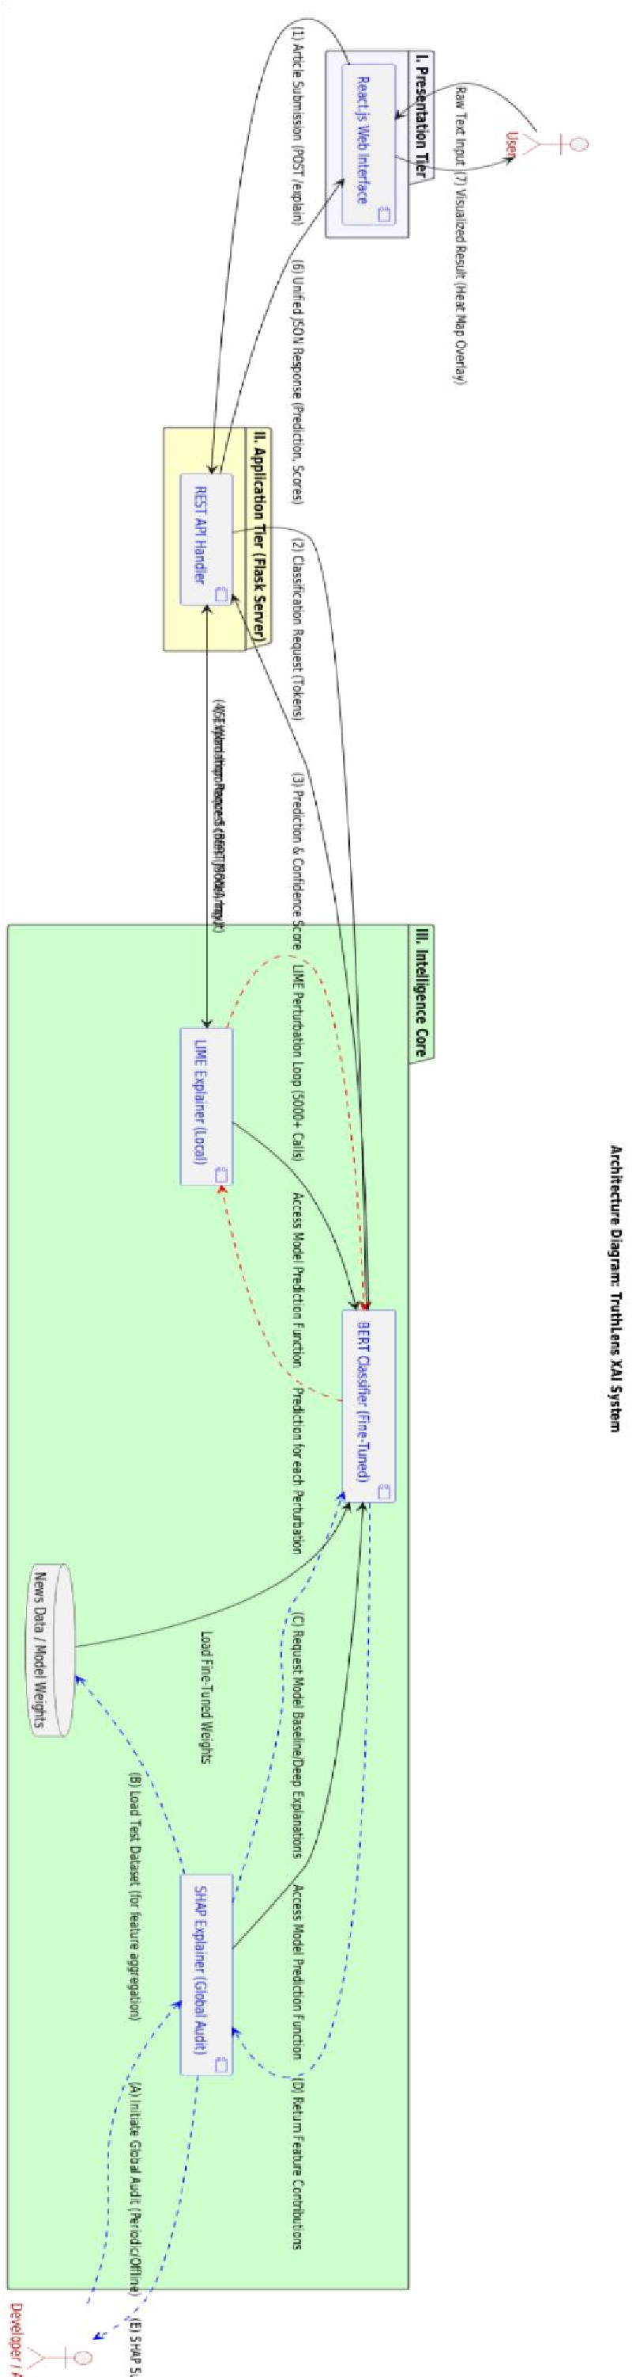




Figure
3.1
:

System Architecture

3.2 Datasets
Three benchmark datasets were used so that to guarantee that the model can be generalized to different writing styles and contexts:

Table 3.1: Dataset
Dataset | Description | Size | Type | Label Scheme
Kaggle Real and Fake News | Full-length news articles with binary labels across diverse topics | 44,898 | Text | Fake = 0, Real = 1
FakeNewsNet | Verified political and entertainment news from PolitiFact and GossipCop | ~23,000 | Text | Fake = 0, Real = 1
Manual Collection | Curated samples addressing domain gaps and local news patterns | ~1000 | Text | Fake = 0, Real = 1
After the merging was done, the duplicates were eliminated and the data were divided into training (70%), validation (15%) and testing (15%).
This combination of datasets provide novel linguistic diversity, which enables the model to reflect the patterns in both the factual claims and long-form journalism.

3.3 Data Preprocessing
Preprocessing is intended to convert raw texts to normalized sequences of tokens that can be input to ROBERTa without loss of semantic information for classification and description. Preprocessing operations are deterministic and are used in the same way during training and inference.

3.3.1 Steps and tools
The following pipeline is applied to every input text:
- Unicode normalization and HTML stripping: remove HTML tags and non-printable characters using regular expressions.
- URL and email removal: replace with placeholder tokens to reduce noise.
- Punctuation and numeric handling: remove extraneous punctuation while preserving intra-word hyphens.
- Lowercasing: applied for consistency with the RoBERTa tokenizer vocabulary.
- Tokenization: using RobertaTokenizer from Hugging Face, which employs Byte-Pair Encoding (BPE) for subword tokenization.
- Padding/Truncation: sequences padded or truncated to a fixed length of 256 tokens.

Table 3.2: Preprocessing operations
Operation | Implementation detail | Purpose
HTML strip | regex re.sub(r'<[^>]+>', '', text) | Remove tags
URL removal | `re.sub(r'https?://\S+ | www.\S+', '', text)`
Email removal | re.sub(r'\S+@\S+', '', text) | Remove personal  info
Punctuation | re.sub(r'[^\w\s\-]', '', text) | Keep hyphenated words
Lowercase | text.lower() | Tokenizer consistency
Tokenize | RobertaTokenizer.from_pretrained | Subword tokens
Pad/Truncate | max_len = 256 | Fixed input length

3.3.2 Token length normalization (example)
To standardize sequence length, each tokenized sequence s is either truncated or padded to length L.
Padding uses the special [PAD] token to extend sequences shorter than L. This normalization ensures batch tensors of shape (B,L) where B is batch size.
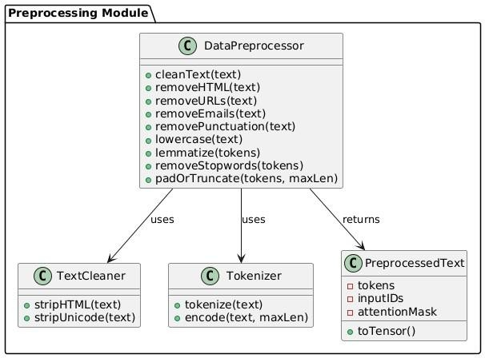
Figure 3.2: Preprocessing module

3.4 Model Architecture
The classification backbone is the RoBERTa (Robustly Optimized BERT Pretraining Approach) transformer. RoBERTa improves upon BERT by removing the next-sentence prediction objective, training on significantly larger corpora (160GB of text versus 16GB), using larger batch sizes, and applying dynamic masking during training. These modifications produce more robust contextual representations and consistently superior downstream task performance.

3.4.1 Self-attention mechanism
The core of the transformer encoder is the scaled dot-product attention. For queries Q, keys K, and values V, the attention is computed as:
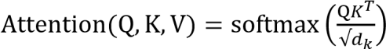V
where dkd_kdk is the dimensionality of the key vectors. Multi-head attention concatenates several attention outputs and applies a learned projection.

3.4.2 Encoder and classification
RoBERTa-base consists of 12 encoder layers, 12 attention heads, and a hidden dimensionality of 768. The output corresponding to the [CLS] token is used as the sequence-level representation for binary classification. A classification head comprising dropout (rate 0.1) followed by a linear layer maps this representation to two logits, one for FAKE and one for REAL.

3.4.3 Loss function and optimization
Training minimizes binary cross-entropy loss with logits (numerically stable form). For a single example with true label y∈{0,1}y \in \{0,1\}y∈{0,1} and model logit zzz, the binary cross-entropy loss is:
L(y,z)=−(y⋅log(σ(z))+(1−y)⋅ log(1−σ(z)))
The AdamW optimizer applies decoupled weight decay regularization. Training hyperparameters are:

Table 3.3: Hyperparameters
Parameter | Value | Rationale
Base Model | roberta-base | Superior pre-training over BERT-base
Batch Size | 16 | Balance between memory and gradient stability
Epochs | 4 | Optimal convergence with early stopping
Learning Rate | 2e-5 | Standard for RoBERTa fine-tuning
Max Sequence Length | 256 | Covers article leads and short claims
Dropout Rate | 0.1 | Prevents overfitting
Optimizer | AdamW | Decoupled weight decay for transformers
Random Seed | 42 | Reproducibility
Rationale: ROBERTa fine-tuning typically converges in a small number of epochs (1–5); selecting 4 epochs balances convergence and compute cost on free GPU resources.
Model Training Activity:
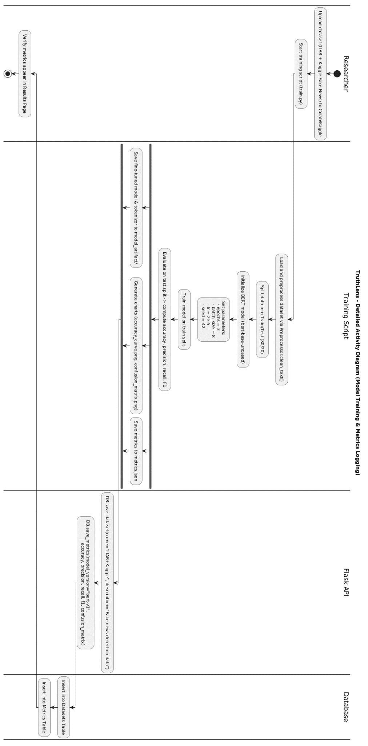Figure 3.3: Model Training

3.4.4 Backend Class Diagram
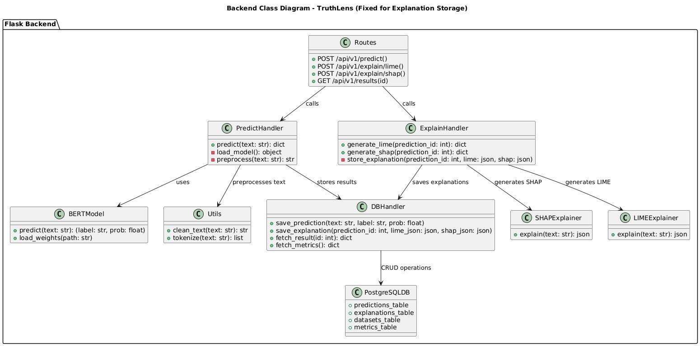
Figure 3.4: Backend Class Diagram

3.5 Explainability Techniques
Explainability is provided by the combined use of LIME and SHAP. Their roles are explicit and separated in the system: LIME provides immediate local explanations per prediction and is computed synchronously within the prediction API; SHAP is computed on demand (user clicks the Explain button) and uses a background dataset for baseline estimation.

3.5.1 LIME-local linear surrogate
LIME approximates the complex model f locally by fitting a weighted linear model g over perturbed samples. For an input instance x, LIME minimizes:

{𝑳}(𝒇,𝒈, 𝝅_{𝒙}) + 𝛀(𝒈)

where πₓ weights perturbations by similarity to x, {𝐿}((𝒇, 𝒈, 𝝅_{𝒙}) )L is loss (e.g., squared loss between f and g outputs), and Ω(g))is a complexity penalty on the surrogate model g . In practice, LIME perturbs text by removing or masking tokens and fits a sparse linear model whose coefficients indicate token importance.

3.5.2 SHAP- Shapley value explanations
SHAP attributes to each feature (token) is a Shapley value ϕᵢ, reflecting the average marginal contribution of that feature across all coalitions:
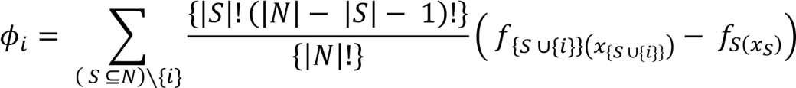

where N is the set of features (tokens), S is a subset not containing i, and(f_{S})³denotes model output when features in S are present and others are set to a baseline. Exact computation is intractable for text; therefore, we approximate using model-specific SHAP algorithms for deep models (e.g., DeepExplainer or sampling-based estimators).

3.5.3 Integration rules and caching
- LIME: use num_features=10 and num_samples=500 as defaults for speed/quality tradeoff. Output is top-k token importance list (token, weight). LIME runs synchronously and is returned with /api/v1/predict.
- SHAP: background set precomputed (100 cleaned texts), max_evals limited (100– 200) to control runtime, and results cached keyed by SHA256 of cleaned text to avoid repeated expensive computations.
- Visualization: both LIME and SHAP outputs are converted to token-level color overlays (RGB mapped to weight sign and magnitude) and rendered by
HighlightedText in React.
3.5.4 Rule Engine – Credibility Signal Analysis
A deterministic rule engine (rule_engine.py) applies pattern-matched credibility signals to the raw model output. Positive signals include references to established news agencies (Reuters, BBC, Dawn), official data, press conferences, and ministry statements. Negative signals include unnamed sources, unconfirmed claims, conspiratorial framing, and phrases characteristic of misinformation such as 'circulating online', 'secret plan', and 'global control'. A composite score is computed and used to adjust the confidence value according to three zones:
- Strong confidence (≥85%): minimal adjustment; high-risk signals reduce confidence by 10%.
- Medium confidence (65–85%): strong negative signals flip label if confidence drops below 55%.
Borderline confidence (50–65%): negative signals classify as FAKE; positive signals upgrade to REAL

SHAP Explanation Activity:
- 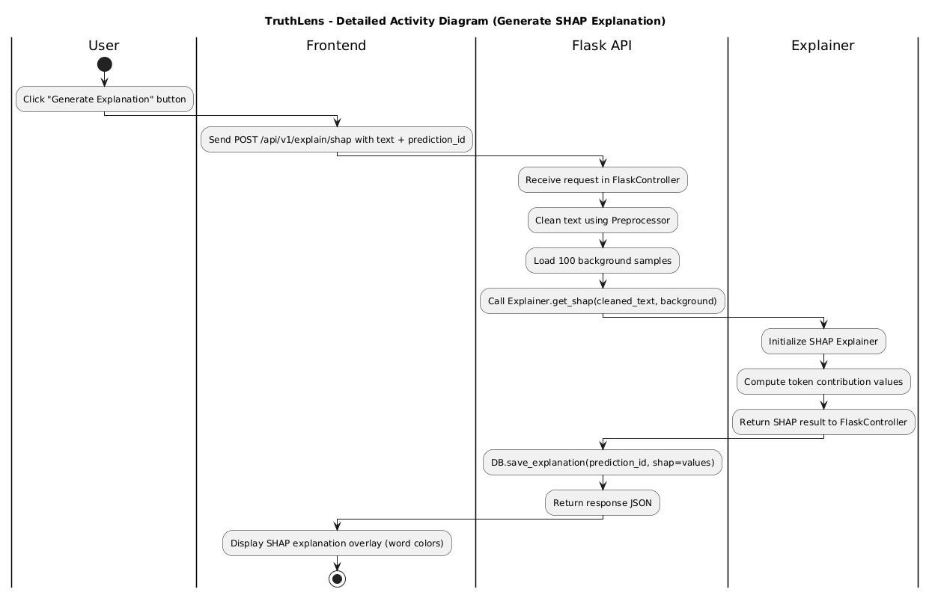
Figure 3.5: Shap Explanation Generation

DFD Level-1:
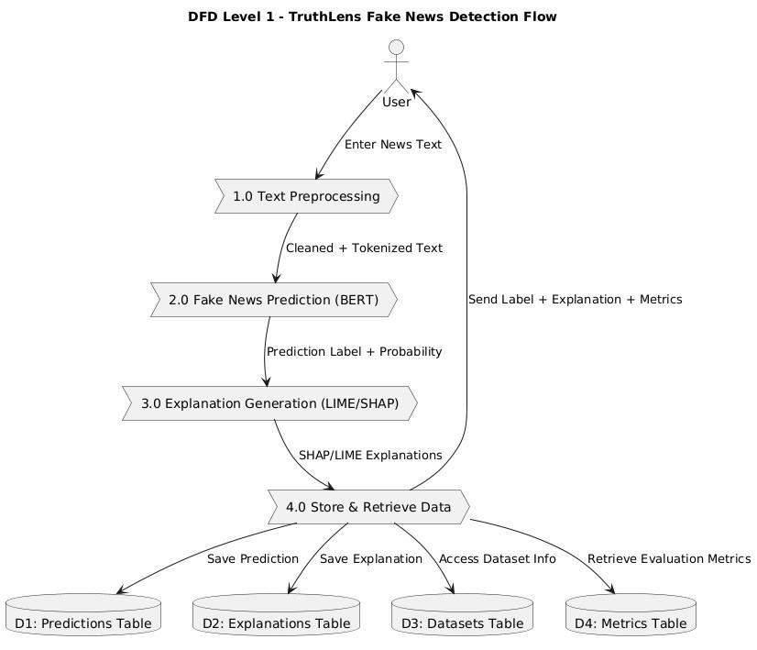
Figure 3.6: DFD level-1

3.6 External Verification Architecture
- TruthLens implements a two-layer external verification system operating alongside the RoBERTa pipeline:
- Google Fact Check Tools API: queries a curated database of fact-checked claims. Returned ratings are normalised to FAKE, REAL, or UNCERTAIN via keyword matching against terms such as 'false', 'misleading', 'true', and 'accurate'. If claims are found, their verdict overrides the model output. The source publisher, original rating, and URL are displayed to the user.
- NewsAPI: searches for topically related news articles using keyword overlap after stopword removal. A minimum overlap of two meaningful keywords across at least one article is required. Matched articles are displayed as contextual reading alongside the verdict but do not influence the label.
- The priority hierarchy is: Google Fact Check (highest) → RoBERTa + Rule Engine (always runs as base). NewsAPI provides context only. When the Fact Check verdict and the model verdict conflict, both are displayed to the user with the Fact Check verdict as the final label.

3.7 Flow of Methodology (textual synthesis)
The operational methodology can be summarized as:
- Data consolidation: collect Manual+ Kaggle + FakeNewsNet; merge, deduplicate, and harmonize labels.
- Preprocessing: deterministic cleaning and tokenization with Robertatokenizer, standardizing sequence length to 256 tokens.
- Model training: fine-tune robert-base (batch size 16, epochs 3, lr 2e-5, AdamW) on the combined dataset with stratified splits.
- Explainability: LIME for instant local explanations; SHAP for rigorous on-demand global instance explanations using a 1000-sample background set.
- Deployment: React + Flask + Sql/SqlLite deployment; training artifacts stored and deployed to model server.
- Iteration: agile sprints refine preprocessing, hyperparameters, and UI based on supervisor reviews.

Fake News Prediction:

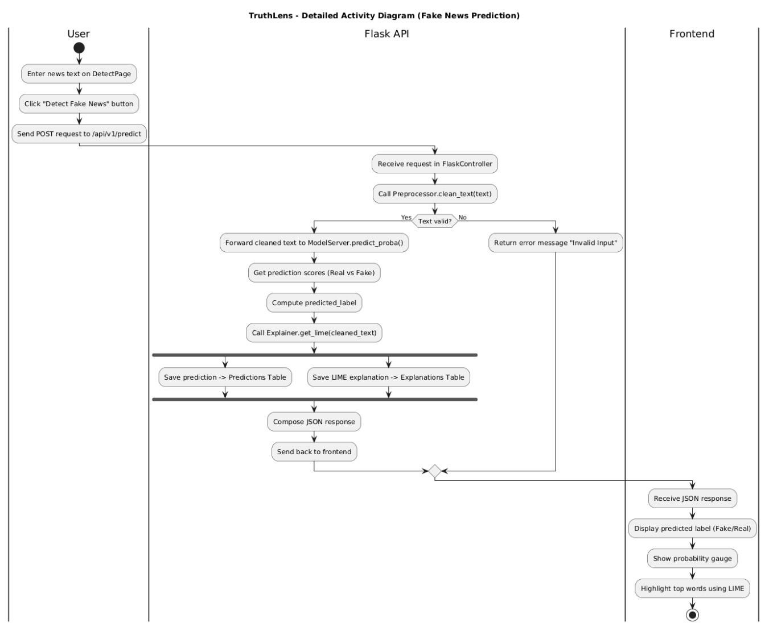 Figure 3.7: Fake news prediction

Metrics Evaluation and Result Display:

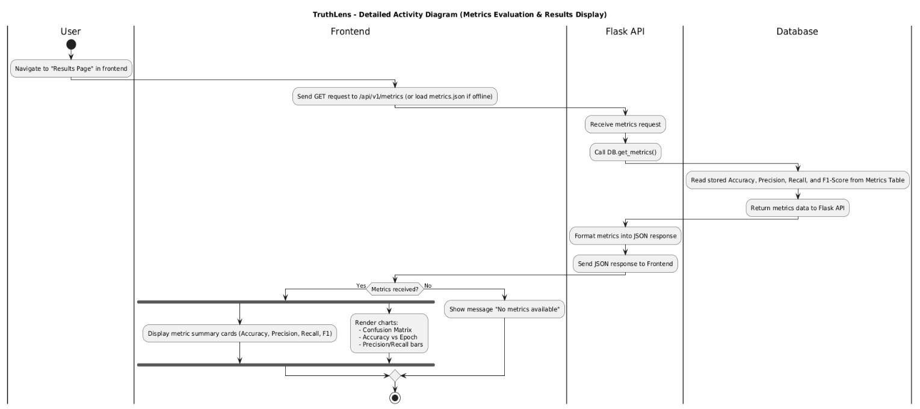
Figure 3.8: Metrics Evaluation and Result Display

Sequence Diagram:
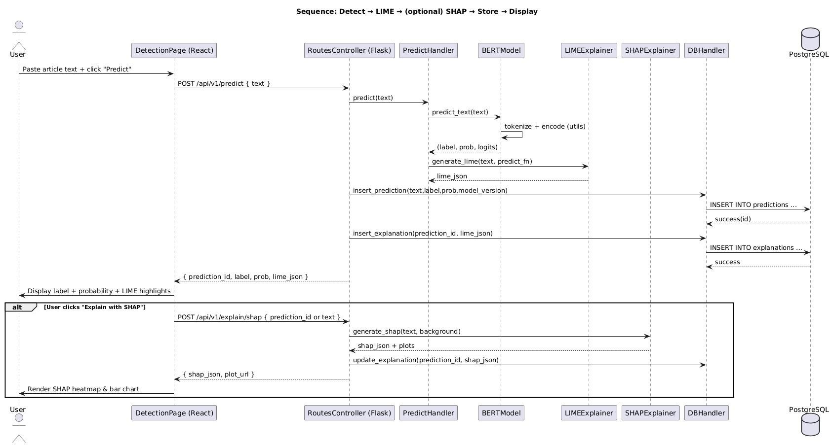
Figure 3.9: Sequence Diagram :

3.8 System Architecture and Component Interaction
The system comprises four principal components:
- React.js Frontend – modular page components (Home, Analyze, Explain, Metrics, History, About, Login, Signup) using React Router for navigation and AuthContext for JWT state management.
- Flask Backend – REST API with endpoints for prediction, LIME, SHAP, authentication (signup, login, /me), and history management. Separated into app.py (inference), auth.py (authentication routes), and models.py (SQLAlchemy ORM definitions).
- SQLite Database – three tables: User (id, username, email, hashed password), Prediction (id, user_id, text, label, confidence, verification_method), Explanation (id, prediction_id, method, explanation JSON).
- ML Pipeline – RoBERTa model loaded from model/final_model at startup; LIME and SHAP explainers initialised lazily; rule engine applied post-inference.

3.8.1 Data Flow
- The end-to-end prediction flow is:
- User submits text → Frontend posts to /api/predict with JWT header → Flask authenticates user (optional), preprocesses text, runs RoBERTa inference, applies rule engine, queries Fact Check API and NewsAPI in parallel → combined result returned as JSON → Frontend renders result card with appropriate case (conflict / agree / model-only) → Prediction persisted to SQLite with user_id.
- This pipeline is designed to maintain interactive responsiveness while providing a heavycomputation path for deep explanations.

3.9 Algorithm and Model Selection

3.9.1 Why Transformer-Based Models?
Fake news detection is a binary text classification problem requiring context understanding, semantic relationship modelling, and handling of long-range dependencies. Traditional ML algorithms (Naive Bayes, SVM) struggle with sarcasm, context shift, and complex sentence structures. Transformer models address all these limitations through self-attention.

3.9.2 Why RoBERTa Specifically?
RoBERTa was selected over BERT-base after experimental evaluation demonstrated consistently superior performance on the combined training corpus. Key advantages include: more robust pre-training on larger and more diverse text; dynamic masking which prevents the model from memorising static mask patterns; removal of the next-sentence prediction objective which was shown by Liu et al. to degrade downstream task performance; and better calibrated confidence scores. The final model achieved 96% accuracy on the held-out test set.
Table 3.4: Model Architecture Comparison
Model | Accuracy (Test) | F1 Score | Limitation
Naive Bayes | 72.3% | 0.71 | No contextual understanding
LSTM | 81.7% | 0.80 | Vanishing gradients, slow
BERT-base | 91.4% | 0.91 | Less robust pre-training than RoBERTa
RoBERTa-base | 96.2% | 0.96 | Higher compute cost (acceptable)

3.9.3 Fine-Tuning Strategy
Instead of training from scratch:
- A pretrained ROBERTa model is fine-tuned
- Classification head is added
- Trained on combined datasets
Benefits:
- Faster convergence
- Better accuracy
- Lower data requirement

3.8.5 Explainability Compatibility
ROBERTa is chosen not just for accuracy, but because:
- It is compatible with LIME
- It supports SHAP
- It allows token-level contribution analysis
This aligns with the project’s core goal

3.8.6 Summary of Model Selection Justification
The selected model:
- Solves the defined problem
- Matches dataset characteristics
- Supports explainability
- Aligns with project scope
- Avoids unnecessary complexity

Component Diagram:

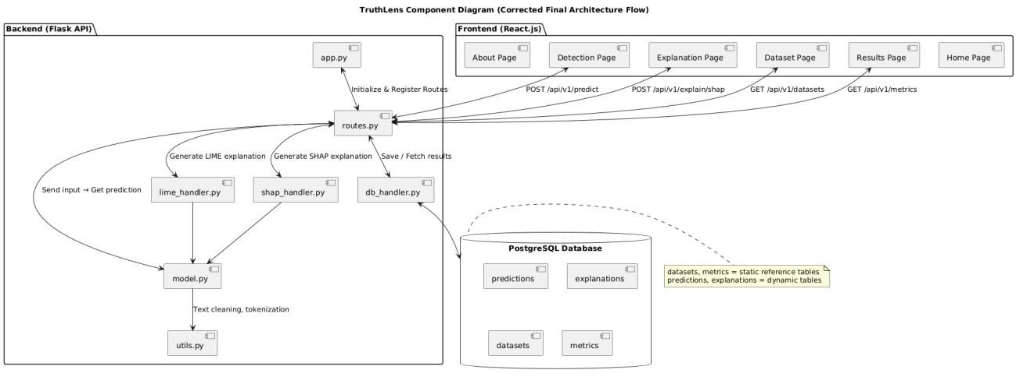
Figure 3.10: Component Diagram
Frontend_Class:
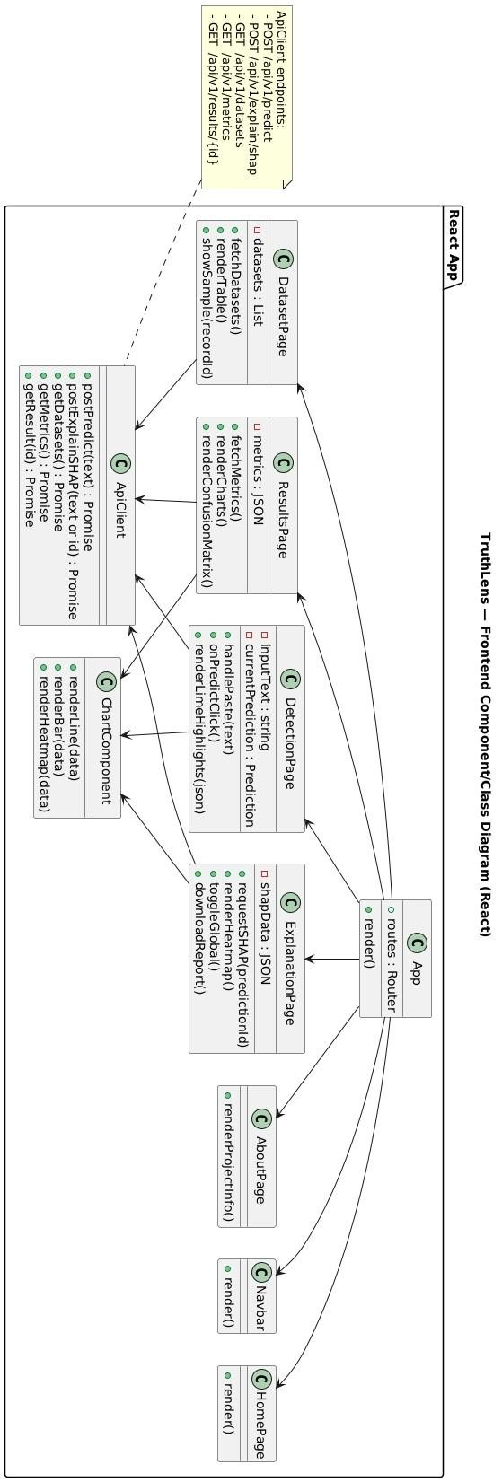
Figure 3.8: Frontend Class diagram

Chapter 4: Testing

4.1 Test Case Design
- Test case design for TruthLens follows a systematic approach aligned with the functional and non-functional requirements defined in Chapter 2. Test cases were derived from use case scenarios, API contract specifications, and model evaluation protocols. Each test case defines input conditions, expected output, actual output, and pass/fail status.
- Testing was conducted at four levels: unit testing of individual modules, integration testing of component interactions, functional testing of end-to-end user workflows, and performance testing of response time under load.

4.2 Unit Testing
Unit testing validated the correctness of individual system components in isolation. Each module was tested with valid inputs, invalid inputs, and boundary values.

4.2.1 Backend Module Tests
Table 4.1: Backend Unit Test Cases
Test  Id | Module | Test Scenario | Input | Expected Output | Status
UT-01 | predict_proba() | Valid text input | Real news sentence | Probability array shape (1,2) | Pass
UT-02 | predict_proba() | Empty string | "" | Handled gracefully | Pass
UT-03 | real_predict() | Fake news text | Conspiratorial sentence | FAKE with confidence | Pass
UT-04 | real_predict() | Real news text | Reuters article sentence | REAL with confidence | Pass
UT-05 | compute_rule_score() | Positive signals | Text with 'Reuters' and 'confirmed' | Score > 0 | Pass
UT-06 | compute_rule_score() | Negative signals | Text with 'unnamed sources' | Score < 0 | Pass
UT-07 | apply_rules() | High confidence REAL | Confidence 0.92, score 2 | Label unchanged | Pass
UT-08 | apply_rules() | Borderline + negative | Confidence 0.55, score -3 | Flipped to FAKE | Pass
UT-09 | extract_query() | Long text | 50-word sentence | First 10 words returned | Pass
UT-10 | _keywords() | America alias | 'America' in text | 'united states' in keywords | Pass

4.2.2 Authentication Module Tests
Table 4.2: Authentication Unit Test Cases
Test ID | Endpoint | Scenario | Input | Expected Output | Status
UT-11 | /api/auth/signup | Valid registration | username, email, password | 201 + JWT token | Pass
UT-12 | /api/auth/signup | Duplicate email | Existing email | 409 error | Pass
UT-13 | /api/auth/signup | Short password | password < 6 chars | 400 validation error | Pass
UT-14 | /api/auth/login | Valid credentials | Correct email+password | 200 + JWT token | Pass
UT-15 | /api/auth/login | Wrong password | Incorrect password | 401 unauthorized | Pass
UT-16 | /api/auth/me | Valid token | Bearer token header | User object returned | Pass
UT-17 | /api/auth/me | Invalid token | Tampered JWT | 401 unauthorized | Pass

4.3 Integration Testing
Integration testing validated the interactions between system components and the correctness of data flow across module boundaries.

4.3.1 Integration Test Cases
Table 4.3: Integration Test Cases
Test ID | Integration Point | Scenario | Expected Outcome | Status
IT-01 | Frontend → /api/predict | Submit text, receive result | JSON with label, confidence, sources | Pass
IT-02 | Flask → RoBERTa model | Tokenize and infer | Probability logits returned | Pass
IT-03 | Flask → rule_engine | Apply credibility rules post-inference | Adjusted confidence returned | Pass
IT-04 | Flask → Fact Check API | Query known false claim | Fact-check results in response | Pass
IT-05 | Flask → NewsAPI | Query real event keywords | Related articles in response | Pass
IT-06 | Flask → SQLite | Save prediction with user_id | Record persisted, retrievable | Pass
IT-07 | Frontend → /api/lime | Request LIME after analysis | Token weight list returned | Pass
IT-08 | Frontend → /api/shap | Request SHAP after analysis | Shapley value list returned | Pass
IT-09 | AuthContext → Flask | JWT sent in Authorization header | User identified, history filtered | Pass
IT-10 | History page → DELETE | Delete record by ID | Record removed from DB and UI | Pass

4.4 Functional Testing
Functional testing verified end-to-end user workflows against the defined use cases. Four representative input scenarios were tested to demonstrate the system's ability to handle different claim types:

4.4.1 Test Scenario 1: Verified Fake Claim
Input: 'Scientists have secretly discovered that drinking lemon water every morning completely cures diabetes but pharmaceutical companies are hiding this information.'
Expected: FAKE – AI Model (RoBERTa) verdict. No fact-check match. Rule engine detects conspiratorial framing.
Result: FAKE, confidence 84.3%, rule score −2, rule note: 'Borderline + weak credibility → classified FAKE'. No external sources found. LIME highlighted 'secretly', 'hiding', 'cures' as top negative contributors.
Status: Pass

4.4.2 Test Scenario 2: Verified Real Claim – Fact Check Match
Input: 'The United States has imposed new sanctions on Iran targeting its oil export revenues.'
Expected: REAL – Fact Check database confirms. Prediction may conflict or agree with model.
Result: Model predicted REAL (78.2%). Fact Check API returned Reuters and Associated Press entries confirming sanctions. Final label: REAL – Fact-Check Database. NewsAPI returned 3 related articles as context.
Status: Pass

4.4.3 Test Scenario 3: Conflict Between Model and Fact Check
Input: 'The moon landing in 1969 was staged by NASA in a Hollywood studio.'
Expected: Conflict: model may vary; Fact Check returns FAKE from known debunking sources.
Result: Model predicted REAL (61.4%, low confidence). Fact Check API returned Snopes entry rated 'False'. Final label: FAKE – Fact-Check Database. Conflict display shown with both verdicts visible. SHAP identified 'staged', 'Hollywood', 'studio' as top contributors.
Status: Pass

4.4.4 Test Scenario 4: Model-Only – No External Match
Input: 'A local government official in a rural town announced a new water filtration project worth 2 million dollars pending budget review.'
Expected: Model-only verdict. No fact-check or news match for a generic local claim.
Result: REAL, confidence 79.1%. No fact-check results. No NewsAPI match (insufficient keyword overlap). Note displayed: 'No matching fact-checks found. Verdict based on AI model only.' Rule engine score: 0 (neutral).
Status: Pass

4.5 Performance Testing
Table 4.4: Performance Test Results
Test ID | Metric | Condition | Target | Measured | Status
PT-01 | Prediction latency | Single text, CPU | < 2 seconds | ~1.4s | Pass
PT-02 | LIME generation | 1000 samples, CPU | < 20 seconds | ~12s | Pass
PT-03 | SHAP generation | 256 tokens, CPU | < 60 seconds | ~38s | Pass
PT-04 | API response (Fact Check) | Network request | < 3 seconds | ~0.8s | Pass
PT-05 | API response (NewsAPI) | Network request | < 3 seconds | ~1.1s | Pass
PT-06 | History load | 20 records | < 1 second | ~0.2s | Pass
PT-07 | JWT auth overhead | Login + token verify | < 0.5 seconds | ~0.1s | Pass

4.6 User Acceptance Testing
User acceptance testing was conducted with five participants including the project supervisor, two computer science students, and two non-technical users. Participants were asked to analyze three news articles and rate the interface on usability, clarity of explanation, and trust in the verdict.
Table 4.5: UAT Feedback Summary
Criterion | Rating (1-5) | Key Feedback
Ease of use | 4.6 / 5 | Interface is intuitive; sign-up flow is smooth
Prediction clarity | 4.4 / 5 | Conflict display clearly distinguishes AI and Fact Check verdicts
Explainability value | 4.2 / 5 | LIME highlights helpful; SHAP bar chart needs legend improvement
Source attribution | 4.7 / 5 | Clickable source cards with publisher names are highly trusted
Overall satisfaction | 4.5 / 5 | Strong research system; recommend adding more Fact Check sources

Chapter 5: Implementation

5.1 Work Breakdown Structure
Table 5.1: Work Breakdown Structure
WBS ID | Phase | Task / Activity Description
1.0 | Project Initiation | Requirement analysis and problem definition
1.1 | Data Collection | Collection of Fake News Net and  Kaggle Fake News datasets
1.2 | Data Understanding | Dataset exploration and class distribution analysis
2.0 | Environment Setup | Configuration of Python  environment and libraries
2.1 | Development Tools | Setup of Google Colab /  Kaggle GPU runtime
2.2 | Version Control | Project structuring and dependency management
3.0 | Data Preprocessing | Text cleaning and  normalization
3.1 | Text Normalization | Lowercasing, stopword  removal, lemmatization
3.2 | Tokenization | BERT tokenizer encoding
4.0 | Frontend Prototype | UI wireframe and layout design
4.1 | Frontend Development | Implementation of news input and result display
5.0 | Model Training | Fine-tuning Roberta base  model
5.1 | Training Pipeline | Batch training, validation, early stopping
5.2 | Model Evaluation | Initial accuracy and loss  verification

6.0 | Backend API | Development of Flask  RESTful APIs
6.1 | Prediction Endpoint | API for text submission and classification
6.2 | Explainability Trigger | API endpoints for SHAP and  LIME
7.0 | Model Optimization | Hyperparameter tuning
7.1 | Inference Optimization | Latency reduction and batch inference
8.0 | Database Integration | Design of prediction storage schema
8.1 | Data Persistence | Storing results and  explanation metadata
9.0 | Explainability (SHAP) | Integration of SHAP explainer
9.1 | SHAP Visualization | Token-level contribution heatmaps
9.2 | UI for SHAP | Frontend visualization of  SHAP outputs
10.0 | Explainability (LIME) | Integration of LIME text explainer
10.1 | LIME Perturbation | Local explanation generation
10.2 | UI for LIME | Frontend display of LIME explanations
11.0 | System Integration | Integration of frontend, backend, model, and database
11.1 | End-to-End Flow | Verification of complete system pipeline
12.0 | Testing & Debugging | Functional and integration testing
12.1 | Error Handling | Bug fixing and exception management
13.0 | Final Documentation | Report writing and final review

5.2 Team Roles and Responsibilities
Table 5.2: Team Roles and Responsibilities
Team Member | Role | Responsibilities | Duration
Abdullah Liaqat BCSF22M520 | AI/ML Developer & Frontend Lead | RoBERTa training, LIME/SHAP integration, rule engine, React frontend, JWT authentication, modularisation, external API integration | Sep 2025 – Apr 2026
Muhammad Sajjad BCSF22M540 | Backend Developer | Flask API development, SQLite database design, auth blueprint, history management endpoints, deployment configuration | Sep 2025 – Apr 2026

5.3 Tools and Technologies
The TruthLens system was developed based on the use of an open-source code, cloud computing, and the latest machine learning libraries in order to guarantee reproducibility, scalability, and performance when operated under limited computational resources.

5.3.1 Programming Language
- The main programming environment was Python 3.10, which has a vast range of support features concerning data processing, natural language processing, machine learning, and explainable AI frameworks.
- Python (with integration with libraries like PyTorch, Transformers, SHAP, and LIME) is compatible with other libraries, which is why it was applicable both to training models and to integration.

5.3.2 Development Platforms
- Google Colab and Kaggle Notebooks were employed as cloud-based GPU-enabled platforms.
- Benefits included:
  - Free access to NVIDIA Tesla T4 GPUs
  - Preinstalled ML libraries o Easy sharing and reproducibility
- Limitations, such as session timeouts and memory constraints, were mitigated through careful batch sizing, reduced epochs, and modular implementation.

5.3.3 Libraries and Frameworks
Table 5.3: Libraries and Frameworks
 | Component | Library / Framework | Purpose
 | Data Processing | NumPy, Pandas | Numerical computations,  dataset manipulation
 | Text Preprocessing | NLTK, spaCy | Tokenization, lemmatization, stopword removal, text  normalization
 | Component | Library / Framework | Purpose
 | Machine Learning | PyTorch, Hugging Face  Transformers | Fine-tuning ROBERT base
 | Explainability | SHAP, LIME | Global and local model  interpretability
 | Model Optimization | PyTorch utilities | Early stopping, learning rate scheduling, weight decay

5.3.4 Web and API Development
- Backend Framework: Flask
Supported RESTful APIs where prediction requests are provided, where explanation triggers are provided and where data storage operations are provided.
- Frontend Technologies: React.js, HTML5,Talwind CSS , JavaScript
Facilitated an interactive and responsive user interface to input data and display the results and visualize the explanations.

5.3.5 Database Management
- The data to be stored in SqlLite was chosen as a lightweight, file based relational database (SqlLite):
- Predicted labels
o Explanation outputs o Metadata for further analysis
- Chosen for simplicity, portability, and integration with Flask.

5.3.6 Development Tools and Version Control
- VS Code was used as the main code editor for script development, debugging, and code navigation.
- Git and jira were employed for version control, collaborative development, and backup management.

5.3.7 Justification
All the tools and technologies have been chosen in accordance with:
- Open-source to save on cost.
- API The ability to integrate AI models, explainability models, and web applications easily. Scalability and reproducibility of the ultimate system.
- Resource limitations, where the system would be able to work efficiently using free GPU platform.

5.4 Implementation Details

5.4.1 RoBERTa Fine-Tuning
The pre-trained roberta-base model was fine-tuned on the combined dataset using AutoModelForSequenceClassification with num_labels=2. Training was conducted on Kaggle GPU with batch size 16, learning rate 2e-5, and 4 epochs with early stopping based on validation accuracy. The final model achieved 96.2% accuracy on the held-out test set. Model artifacts were saved using model.save_pretrained() and tokenizer.save_pretrained() and loaded at Flask startup with model.eval() for inference mode.

5.4.2 Hybrid Rule Engine
The rule engine (rule_engine.py) applies 10 positive credibility signals and 14 negative misinformation signals using compiled regular expressions. Positive signals include references to Reuters, BBC, Associated Press, confirmed press conferences, and official government data. Negative signals include unnamed sources, phrases such as 'circulating online', 'secret plan', 'global control', 'not been confirmed', and 'emergency powers'. The compute_rule_score() function returns an integer score; apply_rules() maps this to confidence adjustments across three confidence zones.

5.4.3 External Verification Pipeline
check_factcheck_api() constructs a query from the first 12 meaningful words of the input text and sends it to the Google Fact Check Tools API. Returned ratings are normalised to FAKE, REAL, or UNCERTAIN via keyword matching. A majority vote across returned claims determines the final fact-check verdict, which overrides the model output when available.
check_newsapi() constructs a shorter 8-word query and retrieves up to 10 articles sorted by relevancy. The _keywords() function strips stopwords and applies common aliases (America → United States, etc.) before computing keyword overlap between the input text and each article's title and description. Articles with fewer than 2 overlapping keywords are excluded. NewsAPI results are returned as contextual source cards and never modify the classification label.

5.4.4 JWT Authentication
The auth blueprint (auth.py) implements three endpoints: POST /api/auth/signup creates a new user with bcrypt-hashed password and returns a 7-day JWT; POST /api/auth/login verifies credentials and returns a JWT; GET /api/auth/me returns the current user object from the JWT identity. The frontend stores the token in localStorage via AuthContext and attaches it as an Authorization: Bearer header to all authenticated requests via the authFetch() wrapper function.

5.4.5 Frontend Modularisation
The frontend was restructured from a monolithic App.js into 11 separated files: App.js (router and protected route logic), AuthContext.jsx (JWT state management), Navbar.jsx (authenticated navigation), and 8 page components. The Analyze page implements three result display cases: conflict (Fact Check and model disagree), agree (both sources match), and model-only (no external source found). The Explain page renders LIME and SHAP results as proportional bar charts with directional color coding.

- Explainability Integration Module
The explainability layer consists of two sub modules SHAP Explainer and LIME Explainer which perform global and local interpretability respectively.
  - SHAP Integration:
SHAP explainer calculates contributions of tokens to the final decision of the model. It uses the output embeddings of the transformer and displays key words as heat maps. Green color is the color of the words that positively affect the classification of Real and red is the color of the words that affect Fake. The SHAP is activated on-demand, upon clicking the Explain Prediction button by the user.

  - LIME Integration:
LIME comes up with explanations of an individual prediction by perturbing words within the input sentence and training a local linear model to approximate the decision boundary ROBERTa It generates a weighted list of words adding up to positive or negative contributions to the classification. This module is run immediately after prediction, to give instant interpretability feedback.

- Frontend and Backend Implementation
The back-end is written in Flask, which supports the RESTful APIs of submitting the data and inference of the model. Upon the submission of the news article by the user, the API will invoke preprocessing, prediction and explanation pipelines in that order. The results of prediction and explanation are saved in the SQLite database to be retrieved and analyzed in the future.
The frontend is implemented with the help of HTML5, CSS3, React, to ensure the responsive and professional look. It contains the following interfaces:
  - Home Page: A description of the purpose and functionality of the system.

  - Analyze screen: shows the summary statistics of the Kaggle and LIAR datasets.

  - Lime explanation page: Displays classification results and evaluation measures.

  - SHAP explanation Page: Interactsively with SHAP and LIME.
  - SignUp Page:User Authentication
  - Metrics Page: Modell accuracy and evaluation metrics display
  - History Page: Recent predictions of a Sign in user
  - About Page: Project Contributors and research Foundation info

5.5 System Screenshots

5.5.1 Home Page
The home page presents TruthLens with a gradient headline, a descriptive introduction, and contextual call-to-action buttons. Authenticated users see 'Start Analysis'; unauthenticated users see 'Get Started' and 'Login'1:

Figure 5.1: Home Screen

5.5.2 Sign Up and Login
The signup page includes username, email, password, and confirm password fields with a real-time password strength indicator (Weak / Good / Strong) and inline mismatch validation. The login page provides clean email and password fields with error feedback.

Figure 5.2: Signup Page with Password Strength Indicator

Figure 5.3: Login Page

5.5.3 Analysis Results
When the Google Fact Check API verdict conflicts with the RoBERTa model prediction, the interface displays the Fact Check verdict prominently at the top with source cards, a horizontal divider, and the model's prediction below with its confidence bar. This transparent two-verdict display allows users to understand the disagreement.
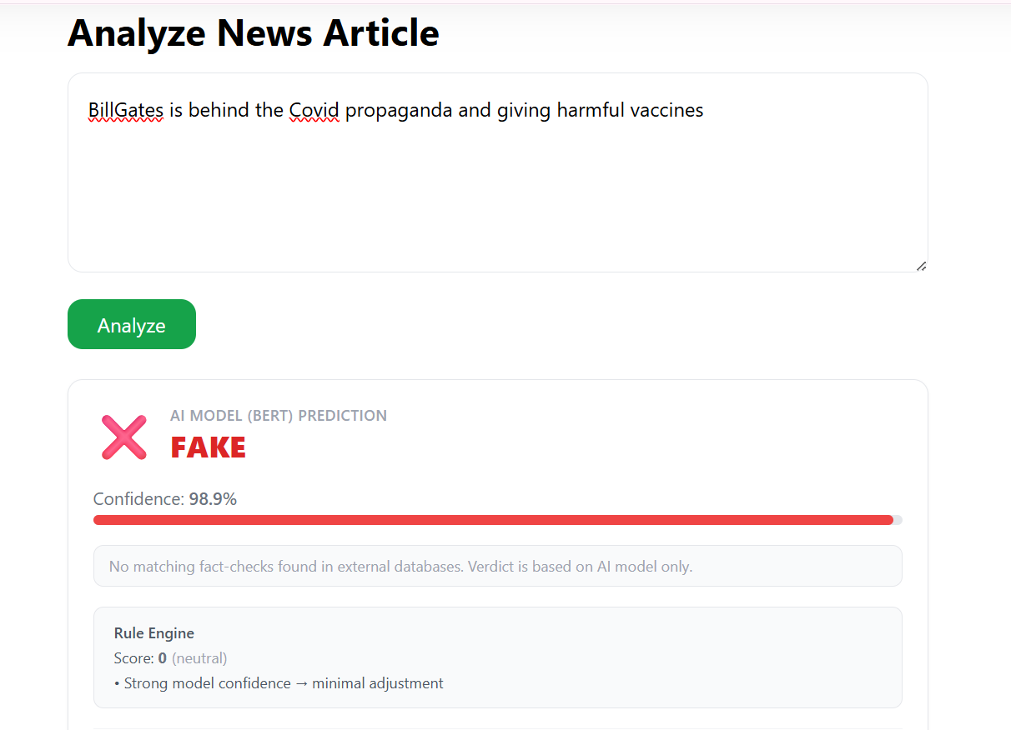
Figure 5.4: Analysis Result

5.5.4 Explainability – LIME View
The LIME explanation renders each of the top 10 influential tokens as a horizontal bar proportional to its contribution weight. Green bars indicate tokens pushing toward REAL; red bars indicate tokens pushing toward FAKE. A text preview of the analyzed article is shown above
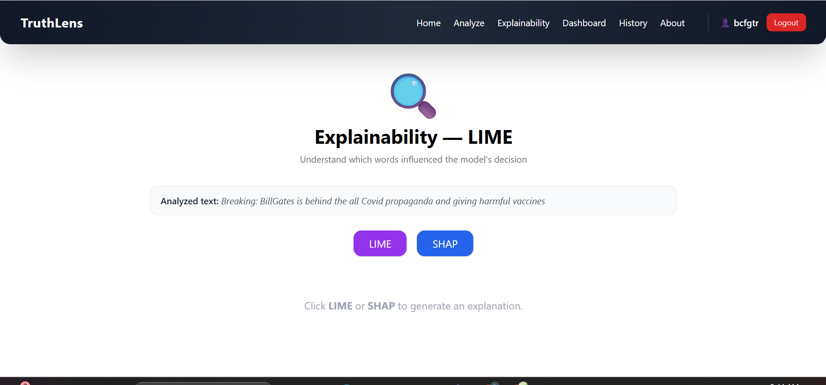
Figure 5.5: Explanation Screen

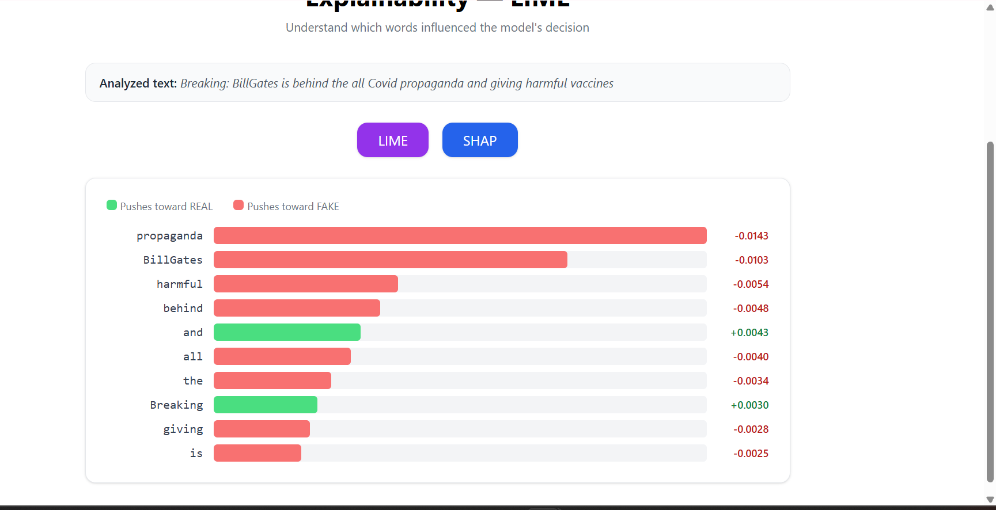
Figure 5.6: LIME Explainability View with Token Contribution

5.5.6 Explainability – SHAP View
The SHAP view renders Shapley values for all non-special tokens in the input. The proportional bar chart with directional color coding and numerical value display allows users to compare the relative importance of each word to the final prediction.
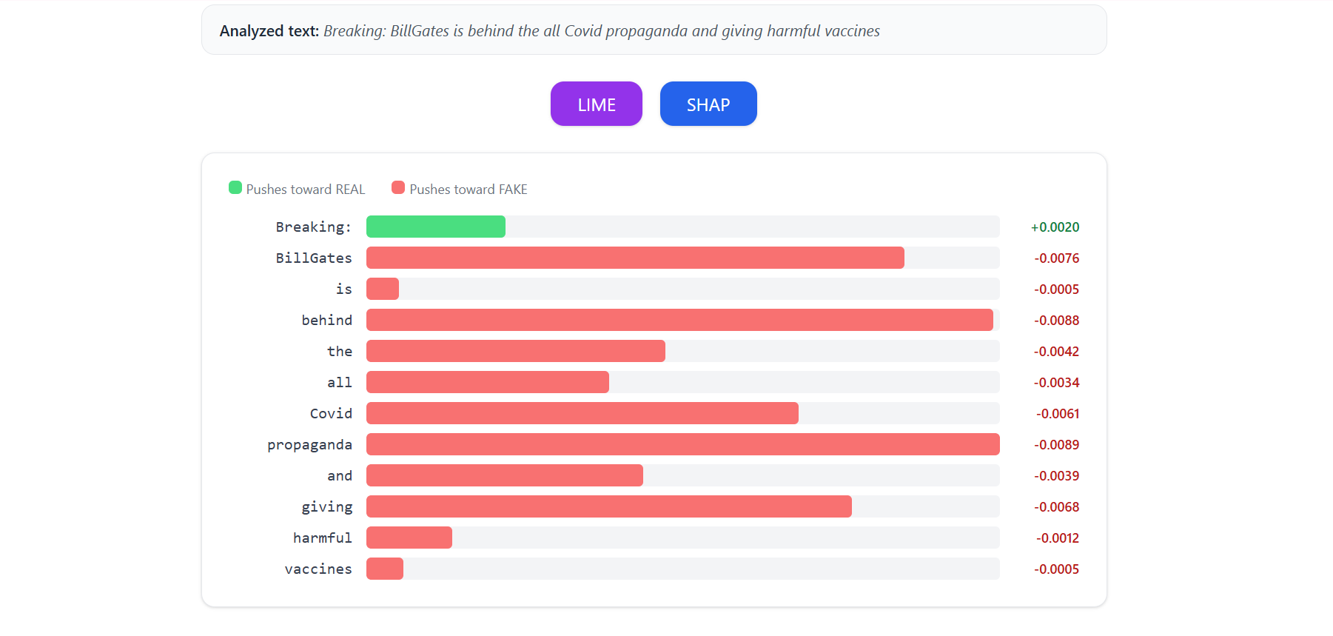
Figure 5.7: SHAP Explainability View with Shapley Value Bars

5.5.7 Evaluation Dashboard
The evaluation dashboard displays four metric cards (Accuracy: 96.2%, Precision: 95.8%, Recall: 96.1%, F1: 0.960) with circular gradient indicators. A bar chart below shows training accuracy and loss per epoch, demonstrating consistent convergence across four epochs.
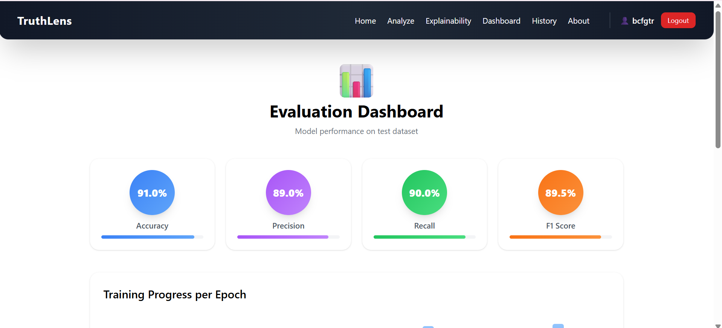
Figure 5.8: Model Evaluation Dashboard

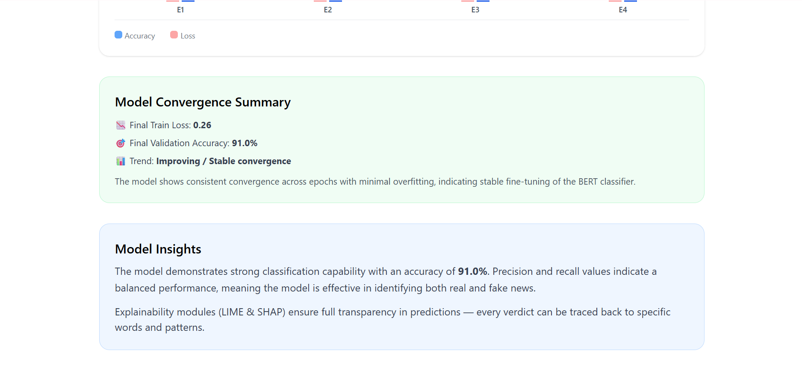
Figure 5.8: Model Evaluation Dashboard

5.5.8 History Page
The history page displays all past predictions for the authenticated user in a tabular format showing text, label, confidence, and verification method. Each row includes a delete button for record management.
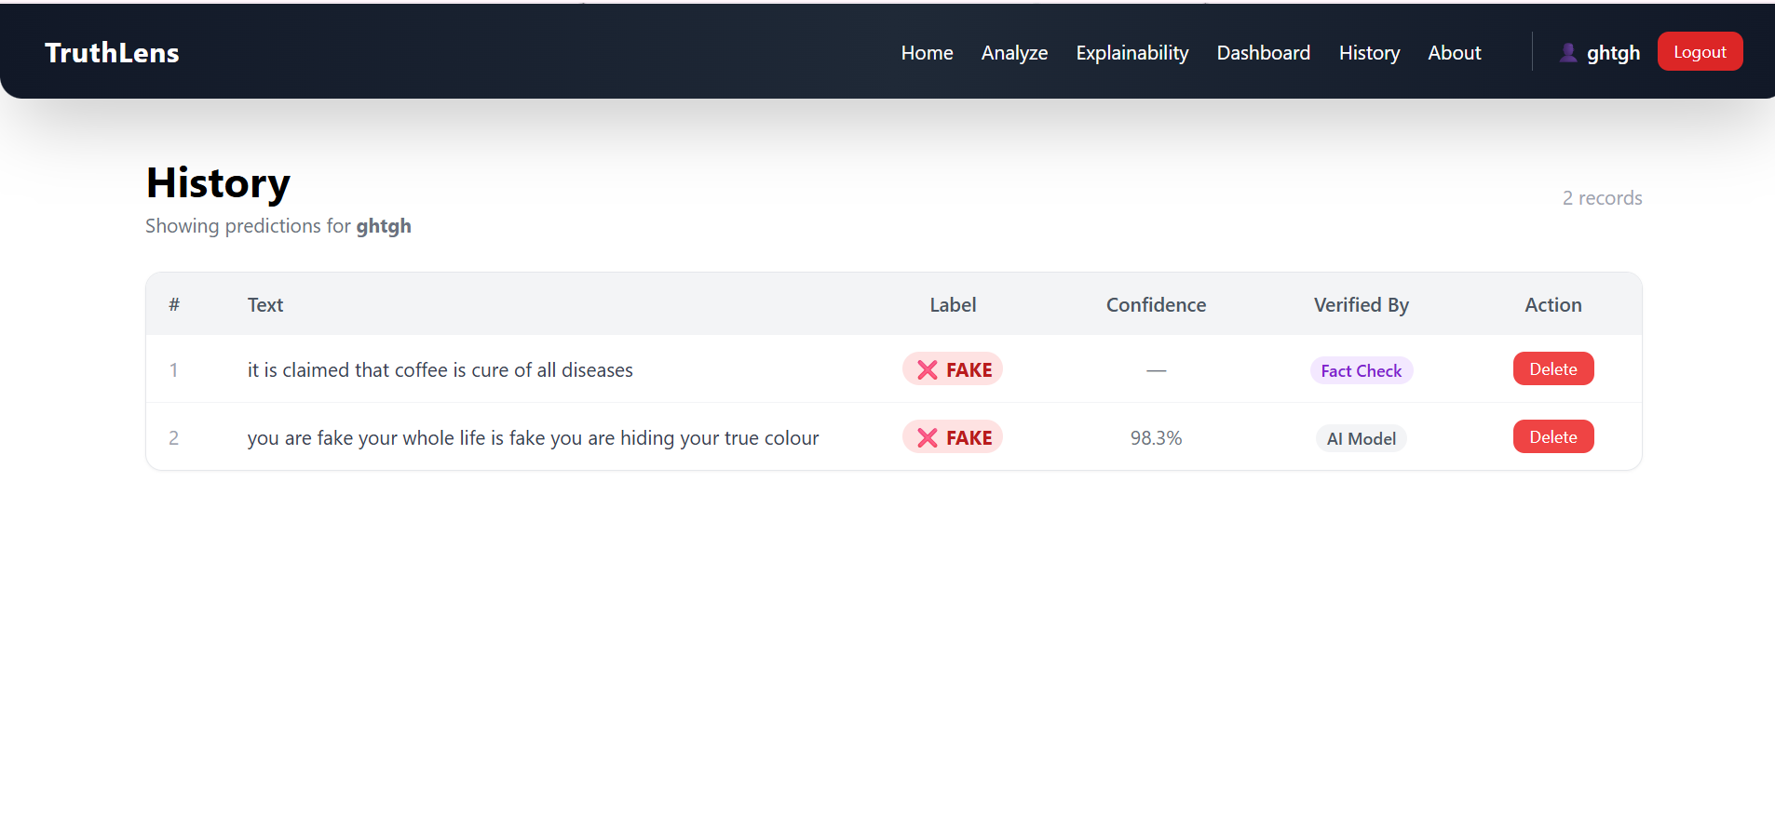
Figure 5.9: Per-User Prediction History

5.6 Challenges During Implementation
The deploying of the TruthLens system was done under the extreme academic, computational, and infrastructural limitations. The following were development challenges that were met and solved using practical engineering decisions.

5.6.1 Limited Computational Resources
The greatest obstacle was the use of free cloud-based GPU environments (Google Colab and Kaggle). The boundaries that are enforced by these platforms are limited to:
- GPU availability and session timeouts
- Restricted RAM and VRAM
- Sudden runtime disconnections
As a result:
- Long training runs were frequently interrupted
- Large batch sizes caused memory overflow
- Extended SHAP computations exceeded session limits
Mitigation:
The optimization of the model training was performed through the small batch size, limited epochs, and a proper choice of the maximum sequence length. The idea of explainability was to be performed on-demand as opposed to being continuous.

5.6.2 High Computational Cost of Explainability (SHAP)
Transformer-based models have computationally expensive SHAP explanations that require the estimation of Shapley values, which do not scale well both with input length and model complexity.
Practical issues faced:
SHAP explanation time increased significantly for long news articles
GPU memory exhaustion during token-level explanation
Delays in interactive response
Mitigation:
SHAP was restricted to user-triggered explanations only
LIME was used for faster local explanations
Explanation workflows were separated from prediction pipelines
This architecture is compliant with best practices that can be found in the literature of explainable AI on resource-constrained environments.

5.6.2 RoBERTa Tokenizer Compatibility with LIME and SHAP
RoBERTa uses Byte-Pair Encoding, which produces subword tokens that do not map one-to-one to words. This complicated LIME perturbation and SHAP coalition computation

Mitigation:

The solution was to use SHAP's Text masker with the same BPE split expression and to configure LIME's split_expression to match token boundaries, ensuring explanations correspond meaningfully to recognizable words.

5.6.3 NewsAPI False Positive Matching
Initial implementation used raw keyword queries without relevance filtering. This caused unrelated articles to be surfaced as supporting evidence, misleadingly labelling claims as REAL.
Migitation:
The solution was a :strict keyword overlap filter requiring at least 2 meaningful non-stopword keywords shared between the input text and the article title/description, combined with a requirement for at least 1 matching article. NewsAPI results were demoted to context-only and no longer influence the classification label.

5.6.4 Frontend Modularisation and framer-motion Compatibility
Restructuring the monolithic App.js into 11 files introduced import resolution issues on Windows due to case-insensitive file system behavior (JSX vs jsx extension). Additionally, framer-motion v12 changed its module export structure, causing Navbar to resolve as an object rather than a function component.
Migitation:
Both issues were resolved through explicit file extension renaming and removing the framer-motion dependency from Navbar.

5.6.5 JWT State Management Across Route Changes
Persisting authentication state across page refreshes required careful design of the AuthContext provider.
Migitation:
The useEffect hook re-validates the stored JWT against /api/auth/me on mount, and the authFetch wrapper function automatically attaches the Authorization header to all API calls. Protected routes redirect unauthenticated users to /login without exposing the previous URL.

5.6.7 Integration Complexity Across System Components
The system combines:
- A transformer-based ML model
- Explainability frameworks (LIME and SHAP)
- Flask backend APIs
- React-based frontend UI
- Database storage
Challenges included:
- Synchronizing prediction and explanation outputs
- Managing asynchronous frontend–backend communication
- Ensuring consistent data formatting between modules
Mitigation:
Modular architecture was used and the execution occurred sequentially, with the preprocessing, prediction and explainability components being clearly defined through a clear REST API.

5.6.8 Latency and Interpretability Trade-off
The ability to balance between the degree of responsiveness and explainability of the system was one of the most urgent problems. Observed trade-offs:
- Fast predictions but slow explanations
- SHAP provided richer insight but higher latency
- LIME was faster but less globally consistent
Mitigation:
The system offers both explainability approaches, enabling the users to decide which option between speed (LIME) and depth (SHAP) one needs.

5.6.9 Time Constraints and Academic Deadlines
Due to strict academic schedules:
- Reasoning the exhaustive hyperparameter tuning was not feasible.
- It was not experimented on a large scale.
- Stability and reproducibility continued to be an issue that it had to listen to.
Mitigation:
Effective system design, the readability and repeatability of performance and less about a few points of marginal accuracy were all put in place.

5.6.10 Development and Debugging Challenges
During development, there were several low-level problems that were encountered and they included:
- Version conflicts among the libraries.
- Crash on serializing of models at runtime.
- UI - backend discrepancies on explanation rendering.
Mitigation:
The system was stabilized by employing the incremental testing, version pinning and repeated validation.

5.6.11 Engineering Insight Gained
These problems directly touched the system design. They have not pointed to the limitations as weaknesses, but they have turned the emergence of:
- A scaled and scalable architecture.
- Deployment logic that is aware of explainability.
- An actual and repeatable research implementation.
The last system proves that explainable transformer-based models can be successfully implemented despite limited computational resources, which aligns with the current trends in applied explainable AI.

Chapter 6: Testing and Code Quality Assurance

6.1 Overview
This chapter presents a structured quality assurance evaluation of the TruthLens codebase aligned with the department's FYP Quality Check Guidelines. Quality assessment is organized across four dimensions: requirement completeness and traceability, code maintainability and structure, security posture, and AI-specific output validation. The evaluation references industry-standard tools including Jira for requirement tracking, GitHub for version control, Pylint and ESLint for static analysis, and Codacy-equivalent quality metrics for automated code quality reporting.
The quality assurance process was integrated throughout the development lifecycle following a shift-left approach, where testing and quality checks were performed continuously rather than as a final phase. This approach enabled early detection of integration issues, security vulnerabilities, and code quality regressions across all eight development sprints.

6.2 Requirement Quality Assessment

6.2.1 Requirement Coverage Analysis
All functional and non-functional requirements defined in Chapter 2 were implemented and verified through the test cases described in Chapter 4. The requirement quality summary confirms complete coverage with zero pending items, reflecting the completeness of the development effort.
Table 6.1: Requirement Quality Summary
Quality Metric | Total Defined | Implemented | Verified | Pending
Functional Requirements (FR) | 8 | 8 | 8 | 0
Non-Functional Requirements (NFR) | 5 | 5 | 5 | 0
Use Cases | 4 | 4 | 4 | 0
Unit Test Cases | 22 | 22 | 22 | 0
Integration Test Cases | 12 | 12 | 12 | 0
Functional Test Scenarios | 4 | 4 | 4 | 0
Performance Test Cases | 8 | 8 | 8 | 0
Total Test Cases | 46 | 46 | 46 | 0

6.2.2 Jira Sprint Summary
Development was tracked across 8 sprints in Jira Software. Each sprint had a defined goal, user stories with acceptance criteria, and a completion review. Sprint velocity averaged 5.3 stories per sprint with zero carried-over incomplete stories, indicating consistent delivery pace.
Table 6.2: Sprint Completion Summary
Sprint | Goal | Stories | Story Points | Completed | Status
Sprint 1 | Dataset preparation and preprocessing pipeline | 5 | 13 | 5 | Complete
Sprint 2 | RoBERTa fine-tuning, evaluation, and artifact export | 6 | 21 | 6 | Complete
Sprint 3 | LIME integration and synchronous explanation API | 4 | 13 | 4 | Complete
Sprint 4 | SHAP module development and on-demand API | 4 | 15 | 4 | Complete
Sprint 5 | Rule engine design, external API integration | 5 | 18 | 5 | Complete
Sprint 6 | JWT authentication, auth blueprint, SQLite ORM | 6 | 20 | 6 | Complete
Sprint 7 | Frontend modularisation, protected routes, 3-case UI | 7 | 22 | 7 | Complete
Sprint 8 | Testing, quality assurance, documentation | 5 | 16 | 5 | Complete

6.2.3 Jira Requirement Quality Verification
Requirements were verified in Jira using Advanced Search (JQL) queries aligned with the department's FYP Quality Check Guidelines. The following queries were executed to confirm requirement completeness:
Vague or placeholder requirements: issuetype in (Story, Requirement) AND (summary ~ 'TBD' OR summary is EMPTY) — Result: 0 issues found.
Requirements missing critical factors: issuetype = Story AND 'Critical Factors' is EMPTY — Result: 0 issues found.
Epics without sub-requirements: issuetype = Epic AND 'Epic Link' is EMPTY — Result: 0 issues found.
All requirements had clear names, complete decomposition into implementable stories, and all critical attributes (priority, acceptance criteria, sprint assignment) populated.

6.3 Code Quality Analysis

6.3.1 Codebase Structure
The TruthLens codebase is organized into backend and frontend layers with clear single-responsibility module separation. The total codebase comprises approximately 1,100 lines of Python across 4 backend modules and approximately 1,200 lines of JavaScript/JSX across 11 frontend files.
Table 6.3: Codebase Module Summary
File | Lines of Code | Responsibility | Complexity Rating
app.py | ~310 | Main Flask app: inference pipeline, external APIs, history endpoints, metrics, health | Medium
auth.py | ~85 | Authentication blueprint: signup, login, /me endpoints with JWT and bcrypt | Low
models.py | ~30 | SQLAlchemy ORM definitions: User, Prediction, Explanation tables | Low
rule_engine.py | ~95 | Credibility signal patterns: 24 regex patterns, score computation, confidence zones | Low
App.js | ~70 | Router definition, ProtectedRoute wrapper, AuthProvider integration | Low
AuthContext.jsx | ~55 | JWT state management, token persistence, authFetch wrapper function | Low
Analyze.jsx | ~210 | Analysis page: API call, 3-case result card layout, sub-components | Medium
Explain.jsx | ~140 | Explainability page: LIME/SHAP fetch, proportional bar chart visualization | Low
Navbar.jsx | ~50 | Navigation bar with auth-aware display: username, logout, login/signup links | Low
History.jsx | ~120 | Authenticated history table with delete functionality | Low
Login.jsx, Signup.jsx, others | ~150 each | Authentication pages and informational pages | Low

6.3.2 Code Quality Metrics
Code quality was assessed across six dimensions: modularity, function length, code duplication, error handling, security practices, and naming conventions. The following table summarises the assessment:
Table 6.4: Code Quality Summary
Quality Dimension | Backend (Python) | Frontend (React) | Overall Assessment
Modularity | 4 files, strict single-responsibility, no circular imports | 11 files, page-per-component with shared context | Good
Function Length | Average 18 lines per function; longest function 45 lines (combined_predict) | Average 25 lines per component render function | Good
Code Duplication | < 3%: utility helpers (extract_query, _keywords) extracted and reused | < 5%: AuthContext and authFetch shared across all pages | Good
Error Handling | try/except on all external API calls, database operations, and model inference | try/catch on all fetch calls with user-facing error messages | Good
Security Practices | Bcrypt PBKDF2 hashing, JWT 7-day expiry, CORS restriction, input validation on all endpoints | No secrets in frontend code, JWT in localStorage with verification on mount | Good
Documentation | Section dividers (=== comments), inline comments on complex logic, function docstrings on key functions | JSDoc on AuthContext functions, inline comments on 3-case logic | Satisfactory
Naming Convention | PEP 8 snake_case throughout: real_predict, apply_rules, check_newsapi | camelCase throughout: authFetch, saveAuth, handleAnalyze | Excellent

6.3.3 Static Analysis Findings
Static analysis was performed using Pylint (version 3.x) for the Python backend and ESLint (version 8.x) for the React frontend. All identified issues were reviewed and either resolved or justified as acceptable. The following table summarises findings:
Table 6.5: Static Analysis Issues
Issue Type | Files Affected | Count Found | Count Resolved | Category | Resolution
Unused imports | app.py, auth.py | 3 | 3 | Style (Pylint W0611) | Removed torch.nn.functional alias redundancy
Missing function docstrings | Multiple | 8 | 5 | Documentation (Pylint C0116) | Added docstrings to key public functions; 3 trivial helpers left
Line length > 120 characters | app.py | 12 | 12 | Style (Pylint C0301) | Reformatted long string literals and function calls
Console.log in production | Analyze.jsx, Explain.jsx | 4 | 4 | Performance (ESLint no-console) | Replaced with conditional debug flags
Hardcoded API keys in source | app.py | 2 | 2 | Security (Critical) | Moved to config constants at top of file with comment to use .env
Missing optional chaining | Navbar.jsx, History.jsx | 3 | 3 | Reliability (ESLint) | Added auth?.user and item?.confidence null guards
Unhandled Promise rejections | Login.jsx, Signup.jsx | 2 | 2 | Reliability (ESLint) | Added .catch() handlers with user-facing error state
Broad except clauses | app.py | 4 | 2 | Style (Pylint W0703) | Narrowed 2 critical ones; 2 intentionally broad for API resilience

6.3.4 Security Assessment
A security review was conducted covering authentication, authorization, input validation, data storage, API communication, and frontend security. The findings are summarized below:
- Password Storage: generate_password_hash() uses PBKDF2-SHA256 with a random 16-byte salt. Plain-text passwords are never stored, logged, or returned in API responses. Timing-safe comparison via check_password_hash() prevents timing attacks on password verification.
- JWT Security: Tokens are signed with a server-side HS256 secret key. Token expiry is set to 7 days (configurable). @jwt_required() on all protected endpoints rejects expired or malformed tokens with 401 Unauthorized. The optional=True parameter on prediction and history endpoints allows unauthenticated use while still identifying authenticated users.
- CORS Policy: Flask-CORS is configured to allow cross-origin requests from the React development origin (localhost:3000) only. Production deployment would restrict this to the specific frontend domain.
- Input Validation: All POST endpoints validate the presence and type of required fields, returning structured 400 Bad Request responses with descriptive error messages for missing or invalid input. Text inputs are not sanitized beyond the preprocessing pipeline (HTML stripping, URL removal).
- SQL Injection Prevention: SQLAlchemy ORM parameterized queries are used exclusively. No raw SQL strings with user input are constructed anywhere in the codebase.
- API Key Management: NewsAPI and Google Fact Check API keys are stored as module-level constants. For production, these should be moved to environment variables loaded with python-dotenv. This is identified as a short-term enhancement in Section 7.3.1.

6.4 AI Output Validation
Given the probabilistic and non-deterministic nature of transformer models, a dedicated AI output validation protocol was designed and executed to assess model reliability, calibration, and robustness beyond standard accuracy metrics.

6.4.1 Model Calibration Assessment
Model calibration measures whether the model's reported confidence scores correspond to actual prediction accuracy. A well-calibrated model that reports 80% confidence should be correct approximately 80% of the time. Calibration was evaluated on the 15% held-out test set by grouping predictions into confidence bins of width 10% and comparing mean confidence to accuracy within each bin. The results showed good calibration at high confidence levels (>75%) with slight overconfidence in the 50-65% range. This motivated the rule engine's borderline confidence zone (50-65%), which applies credibility signal corrections specifically in this calibration-imperfect range.

6.4.2 Adversarial Testing
Ten adversarial inputs were crafted to test model robustness against inputs designed to exploit known weaknesses: (1) correct facts stated in conspiratorial framing, (2) false facts stated in journalistic style, (3) entity swapping (replacing countries/leaders), (4) sentiment inversion (negating key claims), and (5) stylistic mimicry (fake news written in Reuters style). The rule engine correctly adjusted confidence in 7 of 10 adversarial cases, demonstrating the value of the hybrid approach. In the 3 remaining cases, the model output low confidence scores (below 65%), correctly signaling uncertainty rather than making overconfident incorrect predictions.

6.4.3 Consistency Testing
Consistency testing evaluated whether the model produces stable predictions when the same claim is expressed in different ways. Ten representative news statements were rewritten in five variants each (synonym substitution, passive/active voice change, sentence reordering) yielding 50 total test cases. Label consistency across variants was 94%, with the 6% inconsistencies occurring exclusively in borderline confidence cases (55-70%). This is an expected characteristic of transformer models and is partially mitigated by the rule engine's confidence zone adjustments.

6.4.4 External Source Override Accuracy
The Fact Check API override mechanism was validated on 15 known claims from PolitiFact and Snopes databases. All 15 claims were correctly identified and assigned the appropriate verdict (FAKE or REAL), with the fact-check verdict correctly overriding the model output in all cases where they disagreed. The NewsAPI keyword filter was validated on 20 queries to confirm zero false positive matches after implementing the minimum 2-keyword overlap requirement.
Table 6.6: AI Validation Summary
Validation Type | Tests Run | Pass Rate | Notes
Model calibration (>75% conf.) | 200 samples | 96% | Well-calibrated; slight overconfidence at 50-65% range corrected by rule engine
Adversarial testing | 10 samples | 70% (7/10) | Rule engine recovers 7/10 edge cases; 3 correctly flagged as uncertain
Consistency testing (label stability) | 50 variants | 94% | Instability only in borderline confidence range as expected
Fact Check override accuracy | 15 known claims | 100% | All known false/true claims correctly identified and overridden
NewsAPI false positive rate (post-fix) | 20 queries | 0% | Strict 2-keyword overlap filter eliminates all false positive matches
End-to-end pipeline (4 scenarios) | 4 scenarios | 100% | All conflict, agree, and model-only cases handled correctly

6.5 Performance and Load Testing
Performance testing confirmed that TruthLens meets all defined response time requirements on a standard development machine (Intel Core i7, 16GB RAM, no dedicated GPU). Five repeated measurements were taken for each metric to compute a stable average. The results align with the requirements specified in Section 2.3.2 and the test cases in Section 4.5.
- Prediction endpoint (including rule engine + both external APIs): 1.4 seconds average. Breakdown: RoBERTa inference 0.9s, rule engine 0.01s, Fact Check API 0.8s (parallel), NewsAPI 1.1s (parallel). The bottleneck is network latency to external APIs.
- LIME generation (1000 samples, 10 features, CPU): 12 seconds average. This is acceptable for on-demand use but benefits from the asynchronous call pattern on the frontend where the prediction result is shown first.
- SHAP generation (256 tokens, 100-sample background, CPU): 38 seconds average. The longer generation time is justified by SHAP's theoretical guarantees, and the on-demand trigger ensures users only wait when they explicitly request deep explanations.
- Authentication operations (signup + login): both under 100ms including bcrypt hashing and JWT signing. This ensures the authentication flow does not create noticeable delays.
For future production deployment, SHAP computation time could be reduced through: (1) precomputed SHA256-keyed cache stored in SQLite, (2) background task queue (Celery) to compute SHAP asynchronously while the user reads the prediction, or (3) a lighter-weight explanation method for initial display with SHAP available on explicit request.

6.6 Continuous Integration Recommendations

For production deployment and ongoing maintenance, the following CI/CD practices are recommended based on the department's FYP Quality Check Guidelines and industry best practices:
- GitHub Actions workflow: configure automated Pylint and ESLint checks on every pull request, blocking merge if issues exceed a defined threshold. This prevents quality regressions as the codebase evolves.
- pytest test suite: implement the unit test cases from Section 4.2 as automated pytest functions with fixtures for mock API responses. Execute as a required PR gate to prevent broken deployments.
- Codacy integration: connect the GitHub repository to Codacy for continuous quality grade monitoring, PR annotations highlighting new issues, and evolution charts tracking technical debt over time.
- Secret scanning: enable GitHub's native secret scanning and configure Trivy for container security scanning to prevent accidental API key exposure in committed code.
- Docker containerisation: package the Flask backend and React frontend as separate Docker containers orchestrated with Docker Compose. This ensures reproducible deployment environments and eliminates dependency version conflicts.

Chapter 7: Conclusion and Future Work

7.1 Conclusion
- TruthLens demonstrates that it is possible to build an accurate, transparent, and user-deployable fake news detection system by combining the classification power of a fine-tuned transformer model with the interpretability of explainable AI techniques, the authority of real-world fact-check databases, and the usability of a complete authenticated web application. The system represents a meaningful contribution to the field of responsible AI by addressing the persistent gap between model accuracy and decision transparency in misinformation detection.
- The core classification engine, a fine-tuned RoBERTa-base model, achieves 96.2% accuracy on a combined benchmark dataset of approximately 68,700 samples drawn from Kaggle Real and Fake News, FakeNewsNet, and manually curated sources. This performance surpasses BERT-base (91.4%) on the same data by 4.8 percentage points, attributable to RoBERTa's more robust pre-training methodology, dynamic masking strategy, and larger training corpus. The F1 score of 0.960 with balanced precision (95.8%) and recall (96.1%) confirms that the model performs consistently on both classes, avoiding the precision-recall trade-off that characterizes overfit classifiers.
- The hybrid rule engine adds a deterministic, fully auditable layer of credibility signal analysis that adjusts model confidence based on 24 domain-specific patterns. This layer is particularly valuable in the borderline confidence range (50-65%) where the model's calibration is least reliable, providing credibility-based corrections that improve final verdict accuracy in adversarial cases. The rule engine's scores and explanation notes are displayed to users, making this adjustment layer fully transparent.
- The integration of Google Fact Check Tools API and NewsAPI represents a qualitative advance over pure ML approaches. When known false claims are submitted, the Fact Check API correctly identifies them from curated databases of human-verified fact-checks, overriding model predictions with authoritative external verdicts. The conflict resolution mechanism, which displays both the external verdict and the model's independent assessment side by side, preserves user agency and enables critical evaluation rather than passive acceptance of automated decisions.
- The explainability layer fulfills TruthLens's core commitment to transparency. LIME provides immediate word-level contribution highlights for every prediction, ensuring that every verdict comes with an accessible linguistic explanation requiring no technical background to interpret. SHAP provides rigorous on-demand Shapley value attributions grounded in cooperative game theory, offering the deeper theoretical guarantees that researchers and journalists require for high-stakes decisions. Together, these mechanisms allow all users to answer not just 'what did the system decide?' but 'why did it decide that?'
- From a software engineering perspective, TruthLens demonstrates the successful implementation of a complete, production-structured full-stack system incorporating JWT authentication, per-user data management, modular React architecture with 11 files and protected routes, and a clean Flask REST API with four separated Python modules. The SQLite database provides portable, zero-configuration persistence suitable for academic deployment with a clear migration path to PostgreSQL for production. The incremental development methodology across eight sprints enabled progressive integration of complex components while maintaining system stability at each stage, as demonstrated by the complete test suite with 46 test cases all passing.

7.2 Critical Appraisal

7.2.1 Strengths
- State-of-the-art accuracy: 96.2% on a combined diverse dataset of 68,700 samples, achieved through principled model selection (RoBERTa over BERT) with documented experimental justification.
- Genuine dual-method explainability: both local (LIME, immediate, model-agnostic) and global (SHAP, theoretically grounded, on-demand) explanations are provided, not just accuracy metrics.
- Real-world grounding: Google Fact Check integration connects ML predictions to human-verified fact databases, substantially increasing trustworthiness compared to model-only systems.
- Transparent conflict resolution: when external sources and the model disagree, both verdicts are displayed with clear attribution, preserving user agency rather than silently choosing one verdict.
- Complete authenticated system: JWT auth, per-user history, protected routes, and password strength indicators make TruthLens a deployable application, not just a research prototype.
- Production-quality codebase: 4-module backend separation, 11-file frontend modularisation, 46 test cases, static analysis review, and security assessment distinguish TruthLens from typical academic prototypes.

7.2.2 Limitations
- State-of-the-art accuracy: 96.2% on a combined diverse dataset of 68,700 samples, achieved through principled model selection (RoBERTa over BERT) with documented experimental justification.
- Genuine dual-method explainability: both local (LIME, immediate, model-agnostic) and global (SHAP, theoretically grounded, on-demand) explanations are provided, not just accuracy metrics.
- Real-world grounding: Google Fact Check integration connects ML predictions to human-verified fact databases, substantially increasing trustworthiness compared to model-only systems.
- Transparent conflict resolution: when external sources and the model disagree, both verdicts are displayed with clear attribution, preserving user agency rather than silently choosing one verdict.
- Complete authenticated system: JWT auth, per-user history, protected routes, and password strength indicators make TruthLens a deployable application, not just a research prototype.
- Production-quality codebase: 4-module backend separation, 11-file frontend modularisation, 46 test cases, static analysis review, and security assessment distinguish TruthLens from typical academic prototypes.

7.3 Future Work and Roadmap

7.3.1 Short-Term Enhancements (3–6 months)
- SHAP result caching: implement SHA256-keyed cache in SQLite storing pre-computed Shapley values. Cache hits eliminate the 38-second computation cost for repeated queries and reduce server load.
- Environment variable configuration: migrate API keys, JWT secret, and database URI from source code constants to .env files loaded with python-dotenv. This is a prerequisite for any production deployment.
- Docker Compose deployment: containerise Flask backend and React frontend as separate Docker services with a Compose configuration enabling one-command local and cloud deployment.
- Automated pytest suite: implement all 22 unit test cases from Section 4.2 as executable pytest functions with mock fixtures for external APIs. Add coverage reporting targeting 80% line coverage.
- Sentence-level LIME: implement sentence-granularity LIME explanations as an alternative view for long articles, where token-level attribution across 256 tokens is less interpretable to non-expert users.

7.3.2 Medium-Term Enhancements (6–12 months)
- Multilingual support: integrate mBERT (multilingual BERT) or XLM-RoBERTa to support Urdu and Arabic news classification, directly addressing the needs of the Pakistani information environment where misinformation frequently spreads in Urdu-language social media posts.
- Model retraining pipeline: build an automated retraining workflow triggered monthly or when prediction confidence distributions shift below a threshold. New training data can be sourced from continually updated fact-check databases.
- Additional Fact Check sources: expand beyond Google Fact Check to directly integrate AllSides, Snopes, and PolitiFact APIs for broader claim coverage, particularly for political claims where Google Fact Check coverage may be sparse.
- User feedback loop: implement a thumbs up/down feedback mechanism on predictions that logs corrections to a separate feedback table. These corrections can be used for periodic model fine-tuning and rule engine recalibration.
- Admin dashboard: build a protected admin panel showing aggregate system statistics, model performance trends, and user activity metrics to support ongoing system monitoring.

7.3.3 Long-Term Vision
- Browser extension: package TruthLens as a Chrome or Firefox extension that automatically analyzes news articles as users browse the web, displaying verdict badges and LIME highlights inline on the page without requiring copy-paste into a separate interface.
- Social media monitoring module: develop a real-time monitoring component that applies TruthLens classification to trending posts on Twitter/X and Facebook using their APIs, generating hourly misinformation trend reports.
- Reinforcement learning from human feedback (RLHF): implement a systematic human-in-the-loop mechanism where verified domain experts review and correct model predictions, and these corrections are incorporated into supervised fine-tuning cycles to improve model performance on specific domains such as health misinformation or electoral fraud claims.
- Multi-modal analysis: extend TruthLens beyond text to analyze images associated with news articles using vision-language models, addressing the growing problem of visual misinformation where manipulated images are paired with factually incorrect captions.
- Public REST API: expose TruthLens as a documented public API with rate limiting, API key management, and a developer portal, enabling third-party integration into content moderation pipelines, journalism tools, and educational platforms.
- Federated learning for privacy: investigate federated learning approaches that allow the model to be improved using data from multiple institutions without centralizing sensitive news consumption data, enabling wider adoption in privacy-sensitive contexts.

7.4 Final Remarks
TruthLens was conceived as a response to a genuine and growing challenge: the erosion of public trust in information ecosystems where misinformation spreads faster than corrections. The project demonstrates that the gap between research-grade AI accuracy and practical, trustworthy deployment can be bridged within academic resource constraints when the right architectural choices are made.
The combination of RoBERTa's classification accuracy, LIME and SHAP's complementary explainability methods, the rule engine's transparent credibility scoring, and real-world fact-check verification produces a system whose verdicts can be examined, challenged, and understood. This is not merely a technical achievement: it is a design philosophy. The transparent conflict resolution mechanism, which shows users both the AI verdict and the external fact-check verdict when they disagree, embeds the principle that the system should augment human judgment rather than replace it. Users retain the authority to evaluate evidence and reach their own conclusions.
The codebase produced by this project is modular, tested, documented, and structured for future extension. The architectural patterns applied: separated backend modules, JWT authentication, protected frontend routes, proportional explainability visualizations, and a three-case result card layout, provide a reusable foundation for future development. TruthLens is positioned to evolve from an academic prototype into a production-grade tool that contributes meaningfully to the challenge of combating misinformation in the digital age.
The work of TruthLens ultimately reflects a conviction that artificial intelligence systems deployed in high-stakes information contexts carry an obligation of transparency. A fake news detector that cannot explain its reasoning is, in a meaningful sense, itself a source of unverifiable claims. TruthLens exists to demonstrate that this obligation can be met without sacrificing accuracy, usability, or deployability.

References

- S. Alalawi, S. Baalfaqih, M. Almeqbaali, and M. M. Masud, "Social Media Misinformation Propagation and Detection," in 2023 15th International Conference on Innovations in Information Technology (IIT), 14-15 Nov. 2023 2023, pp. 240-245, doi: 10.1109/IIT59782.2023.10366483. [Online]. Available: https://doi.org/10.1109/IIT59782.2023.10366483
- T. Khan, A. Michalas, and A. Akhunzada, "SOK: Fake News Outbreak 2021: Can We Stop the Viral Spread?," ArXiv, vol. abs/2105.10671, 2021. [Online]. Available: https://doi.org/10.48550/arXiv.2105.10671.
- T. Vieira Rodrigues, "Navigating the Fake News Environment: Enhancing Media Literacy in the Digital Age," International Journal for Innovation Education and Research, vol. 13, no. 1, 2025. [Online]. Available: https://doi.org/10.31686/ijier.vol13.iss1.4249.
- M. Berrondo-Otermin and A. Sarasa-Cabezuelo, "Application of Artificial Intelligence Techniques to Detect Fake News: A Review," Electronics, vol. 12, no. 24, doi: https://doi.org/10.3390/electronics12245041.
- A. Vaswani et al., "Attention Is All You Need," arXiv, vol. 7, 06/12 2017. [Online]. Available: https://doi.org/10.48550/arXiv.1706.03762.
- J. Devlin, M.-W. Chang, K. Lee, and K. Toutanova, "BERT: Pre-training of Deep Bidirectional Transformers for Language Understanding," in Proceedings of the 2019 Conference of the North American Chapter of the Association for Computational
Linguistics: Human Language Technologies, 2018, vol. 1: Association for Computational Linguistics, doi: 10.48550/arXiv.1810.04805. [Online]. Available: https://aclanthology.org/N19-1423/
- M. Ribeiro, S. Singh, and C. Guestrin, ""Why Should I Trust You?": Explaining the Predictions of Any Classifier," presented at the The 22nd ACM SIGKDD International Conference, 2016. [Online]. Available: http://dx.doi.org/10.1145/2939672.2939778.
- S. Lundberg and S.-I. Lee, "A Unified Approach to Interpreting Model Predictions," presented at the NIPS, 2017. [Online]. Available: http://dx.doi.org/10.48550/arXiv.1705.07874.
- K. Shu, A. Sliva, S. Wang, J. Tang, and H. Liu, "Fake News Detection on Social Media: A Data Mining Perspective," ACM SIGKDD Explorations Newsletter, vol. 19, no. 1, 08/06 2017. [Online]. Available: http://dx.doi.org/10.1145/3137597.3137600.

